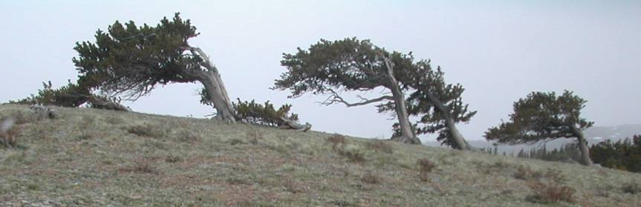

Genetics of five-needle pines and rusts in mountain landscapes –
Conservation, utilization and evolution in a changing climate
International IUFRO Conference * June 15-21, 2014 * Fort Collins, CO, USA
The 2014 meeting of the IUFRO 2.02.15 Breeding and Genetic Resources of Five-Needle Pines working group will continue in the tradition of the past meetings in the Russian Federation (2011), South Korea (2008), Romania (2006), and United States of America (2001) and the 1992 conference on subalpine stone pines (Switzerland) by facilitating international exchange of the latest findings on genetic variation, conservation and tree improvement efforts with this important group of conifers worldwide (http://www.iufro.org/science/divisions/division-2/20000/20200/20215/). Many of these species are vulnerable to a range of abiotic and biotic factors including climate change and blister rust. Pinus squamata in China has only 32 trees remaining in natural forests and several other species are rated as endangered or vulnerable by the IUCN Red List. Pinus albicaulis has been proposed for listing under the Endangered Species Act (ESA) in the United States and, along with Pinus flexilis, is also of concern in Canada. It is however also an exciting time for work with the white pine species around the world. Genomic tools are now becoming available for use in conifers such as Pinus lambertiana, Pinus albicaulis and Pinus cembra, blister rust genetic variation studies are exploring the species evolutionary histories and guiding gene conservation efforts, resistance programs are making substantial progress, conservation plans are being developed and implemented, and seed orchard development and tree improvement efforts continue in the commercial species.
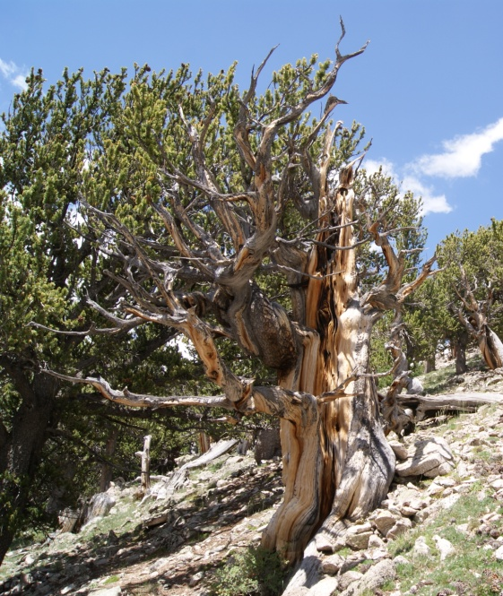
We will be soliciting titles for potential talks and posters for the 2014 meeting in all areas of five-needle pine genetics, including evolutionary biology, landscape genomics, assisted migration, genecology, phylogeography, gene conservation, progeny testing, and disease and insect resistance, etc.
Eight species of white pines exist in the western U.S. and substantial new efforts have been undertaken on many of them in the last 10 years. The meeting venue is the front range of the Rocky Mountains, offering field trip opportunities to see and learn about current research and conservation of Pinus flexilis and Pinus aristata; a post-meeting trip is also being considered to the Greater Yellowstone area to highlight restoration efforts for Pinus albicaulis and Pinus flexilis.
This meeting will serve as an international forum for those involved in genetics and conservation of 5-needle pines (white pines) – and joint sessions with the IUFRO 7.02.05 Rust of Forest Trees group (http://www.iufro.org/science/divisions/division-7/70000/70200/70205/) and Strobusphere (http://dendrome.ucdavis.edu/strobusphere/) should add further diversity and collaborative opportunities.
Please contact Richard Sniezko (rsniezko@fs.fed.us) and Anna Schoettle (aschoettle@fs.fed.us) to be added to the mailing list.
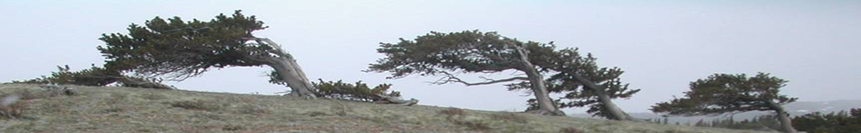
Genetics of five-needle pines and rusts in mountain landscapes –
Conservation, utilization and evolution in a changing climate
International IUFRO Conference * June 15-21, 2014 * Fort Collins, CO, USA

Name _______________________________ Email address __________________________________

Are you likely to attend the meeting?
Yes __________
No __________
Maybe __________

Will you want to present?
Yes __________
No __________
Maybe __________

Would you consider a:
Oral presentation ___________
Poster presentation ___________
Either type of presentation ___________

Are you interesting in a post-meeting multiple day field trip to the Greater Yellowstone Area?
Yes __________
No __________
Maybe __________

Would you have additional family members joining you?
Yes __________
No __________
Maybe __________

Please send responses to Richard Sniezko (rsniezko@fs.fed.us) and Anna Schoettle (aschoettle@fs.fed.us) to be added to the mailing list.

