The IUFRO Work Unit on Invasive Species in International Trade will hold its 4th meeting in Qingdao, China October 23 - November 1, 2013.

At the last meeting, in Tokyo, the 65 participants learned much about key forest pests such as pinewood nematode and oak wilt, shown here in photos from our field trip.
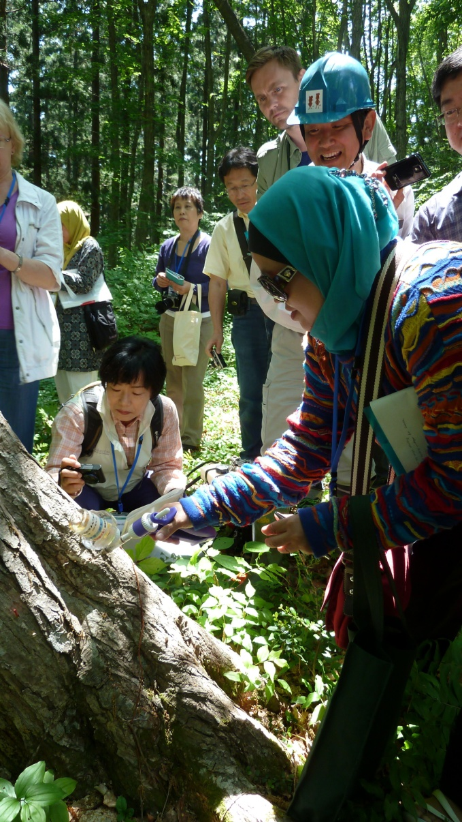
We will hold the next meeting in China, in conjunction with 2nd INTERNATIONAL CONGRESS on BIOLOGICAL INVASIONS (ICBI), October 23-27, 2013.

Kerry Britton, coordinator of the IUFRO WP, has been invited to organize a session at the Congress on Sustainable Management of Forest Pests, in collaboration with Dr. Jianghua Sun.

Other ICBI sessions of particular interest to IUFRO participants will be:

Biological Invasions under Global Change
Pathways: management, detection, and simulation
Risk Assessment techniques
Invasiveness and Characteristics (Genetic, Phenotypic plasticity, Ecological adaptation)
Influences of Biotic Interactions in Biological Invasions
Impacts on Functions of Ecosystem Services
Biocontrol, Genetic Management and Ecological Manipulation of IAS
Sustainable Management of Invasive Alien Species in Forest
Increasing the profile of Invasive species science-based approaches in the International policy arena
Invasions in Mega-diverse Developing Countries: Scientific and Policy Problems
Novel interactions in emerging vector borne diseases
Invasiveness of bio-fuel plants

To enhance linkages to regulatory world, our IUFRO 7.03.12, will also meet jointly with the International Forestry Quarantine Research Group (IFQRG). IFQRG will meet immediately after the Congress (Oct 28 – Nov 1). The IUFRO WP and IFQRG have many common interests, but are at different places on the continuum between science and international standard formulation in service of the IPPC.

IUFRO members are invited to present papers during IFQRG in the following topic areas:
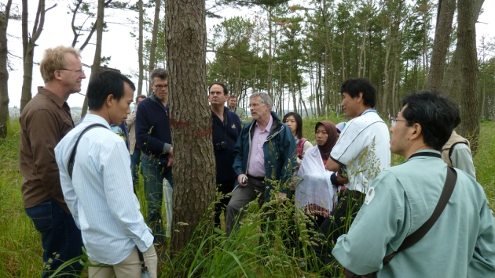
1) Phytosanitary policy and regulations
2) Wood treatments
3) Pest detection techniques
4) Pest epidemiology

The stars align for a conjunction of these three important groups in a golden opportunity to interact with Chinese scientists working the areas of key interest to IUFRO Work Unit members. You can’t afford to miss it!

