Damage from boring trees with increment borer
Summary of presentation by John Pronos, R5 Forest Health Protection, 2003

Disadvantages of boring trees with an increment borer

- Physical reduction in tree strength
- Wounds may lead to discoloration/stain
- Wounds may lead to decay

Obviously, the smaller the tree the more physically damaging the wound.
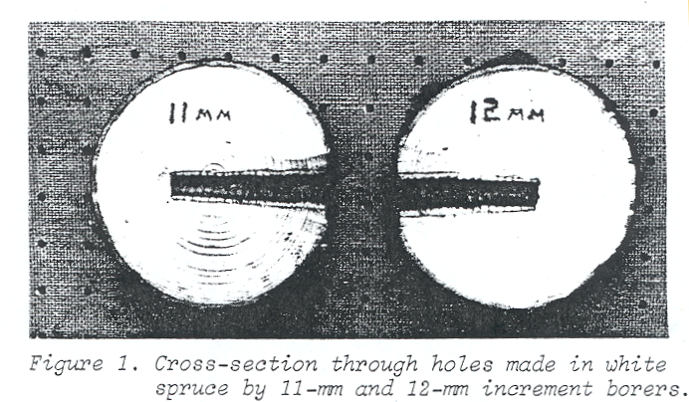

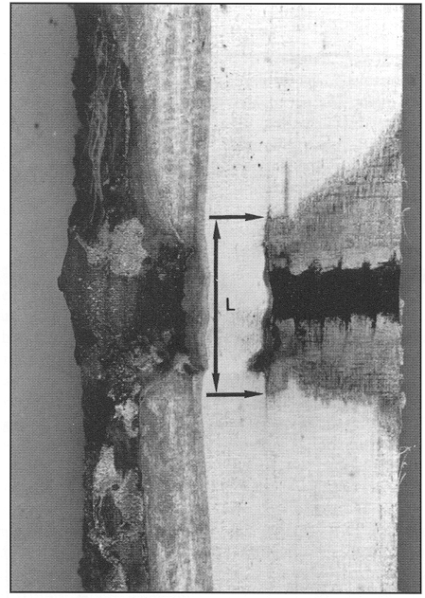

Although the wound from an increment borer is relatively small, it is an entry court for stain and decay fungi. A growing tree will put new wood down to close the wound, but this takes time.

Causes of Discoloration/stain after wounding

- Physical/chemical changes (oxidation)
- Biochemical changes caused by wound reaction of the tree (CODIT stands for Compartmentalization of Decay in Trees)
- Biological changes (molds and sapstains tend to be pioneer species; decays take a little longer to develop)

Types of Wounds That May Lead to Decay

- New wounds made in cambium of all live trees

Spores of decay fungi are plentiful in the forest air, similar to mold spores in a kitchen. Any opening through the bark, into or past the cambium, provides an infection court for the germination and establishment of a decay fungus.
- Wounding of previously formed barrier walls in trees with decay (CODIT)

The living tree reacts to wounding by walling off the tissue formed before the wounding event. The walls act to limit the development of a decay column. When a wall is broken by a subsequent wound, the decay is free to spread to all the new wood formed beyond the wall that was formed at the earlier wound.

Information From the Literature

- U.S. conifers (primarily pines and Douglas-fir) did not develop decay after boring
  - Borer hole often fills with pitch, which may delay callus formation

- Trees may callus over hole in 1 to 5 years, but sometimes cankers form in hardwoods

Probability of Decay From Wounding

- Diffuse Porous Hardwoods>Ring Porous Hardwoods
- Hardwoods>Conifers
- Non-Resinous Conifers>Resinous Conifers

Hemlocks and true firs are non-resinous conifers, and develop decay much faster than pines and Douglas-firs.

Weak Points in the Literature

- Most studies done in eastern North America on hardwoods
- Variable study times (1-10 years)
- Did not differentiate between stain and decay
- Did not identify stain or decay organisms
- None have shown increment borer wounds that contributed to a tree failure

Recommendations

- Only core a tree when information is essential
- Use the smallest borer/drill bit possible
- Take as few cores as possible
- Don’t treat borer or hole with wound dressings; don’t put core back in tree.
- Be especially reluctant to bore diffuse-porous hardwoods
- Only bore in as far as needed to meet minimum shell thickness

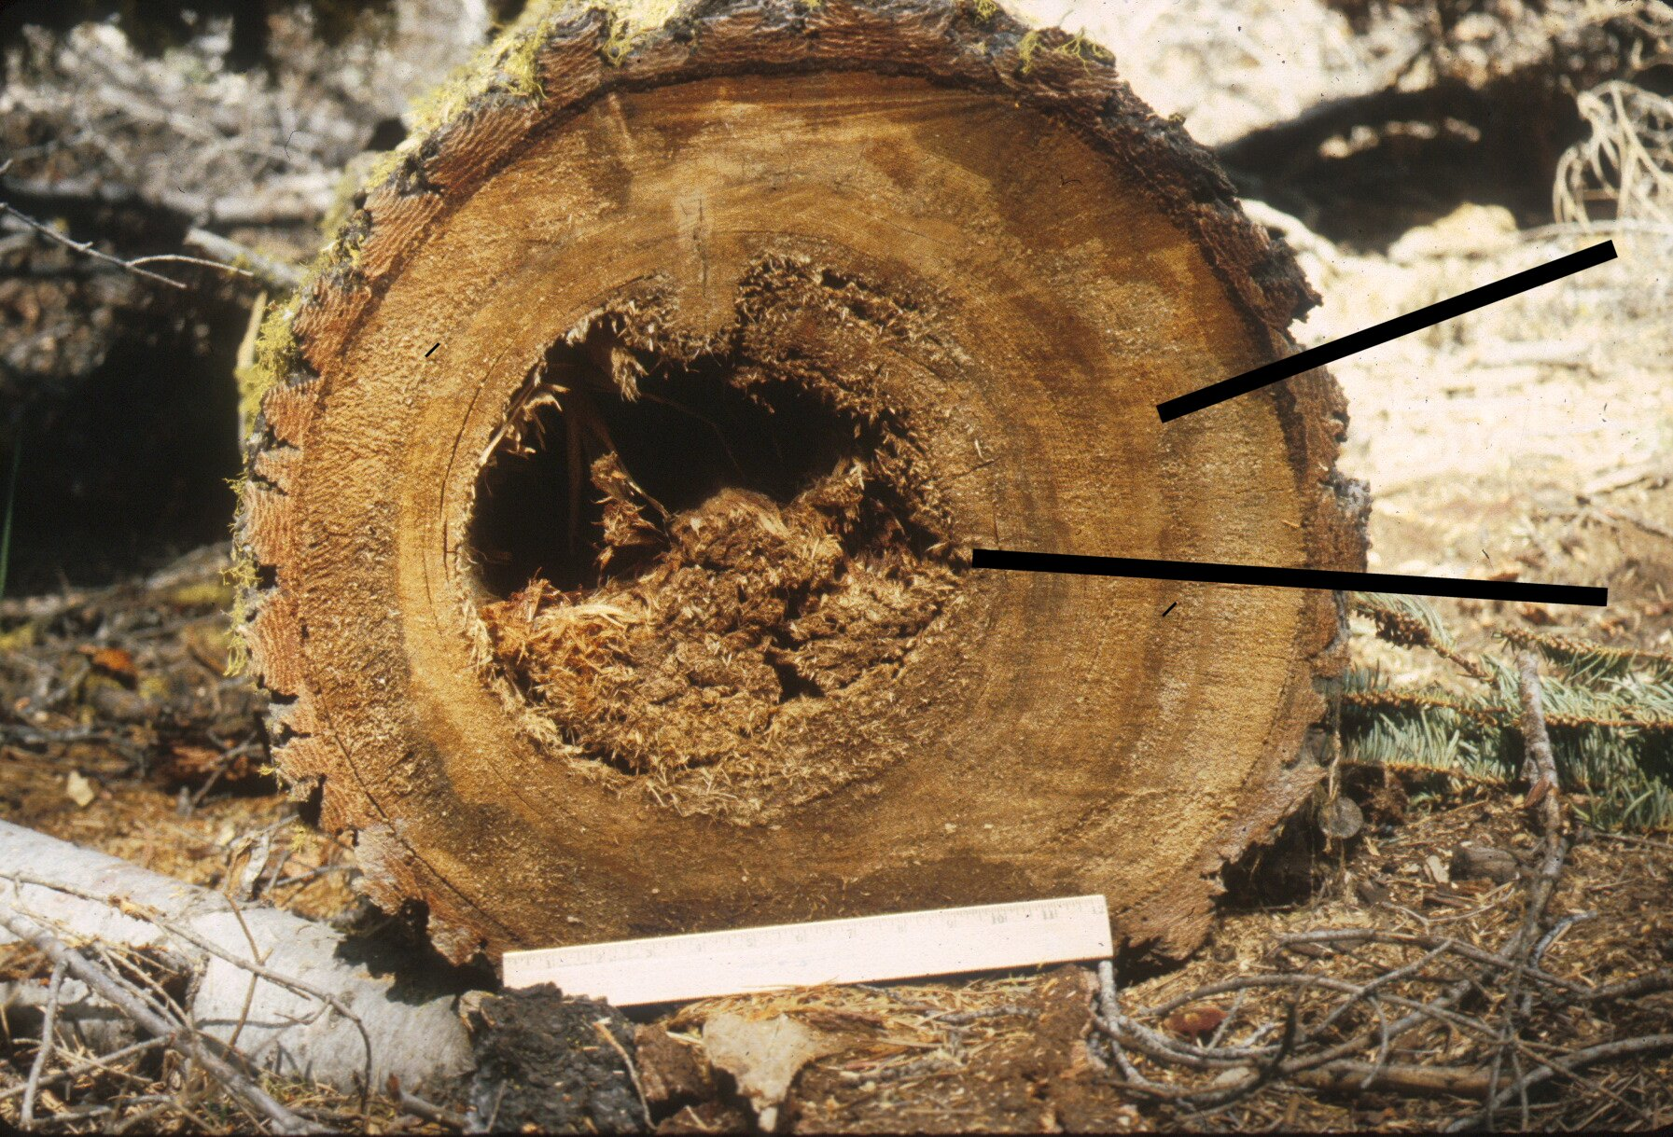

Only core to minimum depth to avoid breeching walls that limit a decay column.

