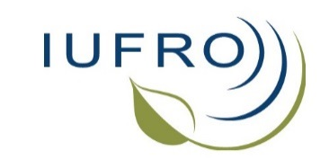

Report to the Board, April 2015 to October 2016

Compiled by Ecki Brockerhoff (Coordinator Division 7) Eckehard.Brockerhoff@scionresearch.com, Elena Paoletti (Coordinator RG 7.01 “Air Pollution and Climate Change”), Jolanda Roux (RG 7.02 “Pathology”), and Andrew (“Sandy”) Liebhold (RG 7.03 “Entomology”)

Table of Contents
News from our Research Groups and Working Parties 1
Other news from Division 7 and changes in coordinators 4
Acknowledgements 4
Key issues discussed and latest findings in the field 4
Newsletters and list-servers 5
Upcoming Division 7 conferences and meetings 6
Division 7 meetings and conferences in 2015-2016 7

News from our Research Groups and Working Parties

In the period since the last Board Meeting in April 2015, the Forest Health Division of IUFRO maintained its usual high level of activity among the three research groups and most working parties. There were 12 conferences of Division 7 working parties and research groups; seven of these took place in Europe, two in Asia, two in North America and one in South America. A list of meetings held recently and upcoming events is given below.

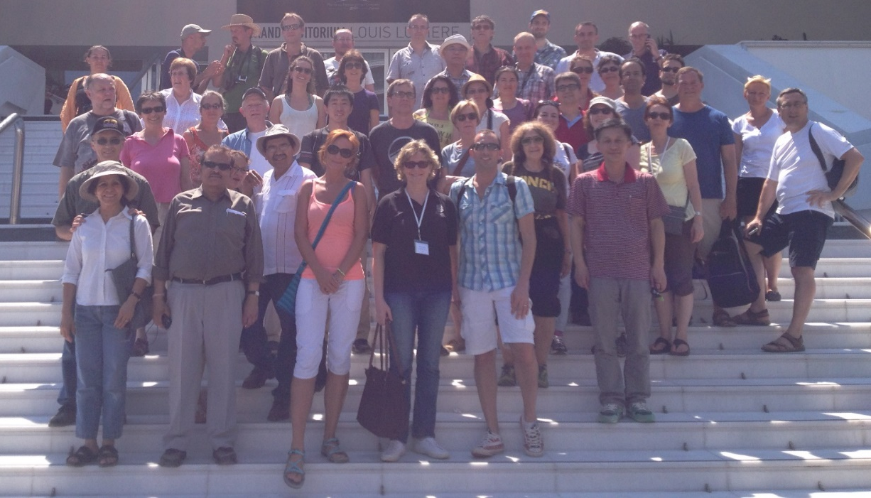
Participants of the biennial conference of Research Group 7.01, “Impacts of Air Pollution and Climate
Change on Forest Ecosystems”, in Nice, France
Research Group 7.01, “Impacts of Air Pollution and Climate Change on Forest Ecosystems”, held its biennial conference in Nice, France, in June 2015, where all the WPs met and organized sessions. The conference was attended by 122 delegates from 38 countries. A wide range of topics received attention covering experimental, monitoring, and modelling studies on air pollution and climate change impacts on forests worldwide. Proceedings were published in two peer-reviewed journals, iForest (www.sisef.it/iforest/archive/?action=collection&arg=IUFRONICE) and Environmental Pollution (www.sciencedirect.com/science/journal/02697491/vsi/109H446P4JV). At the conference it was agreed that WP7.01.02 and 7.01.04 merge to facilitate concurrent application of physiological, genetic and molecular approaches. The merged WP will continue as WP7.01.02, “Genetic, biochemical and physiological processes”.

In addition, RG7.01 was involved in a number of interdisciplinary activities including two IUFRO Task Forces. The new Task Force on ‘Climate Change and Forest Health’ includes a large membership from many organisations and is coordinated by Elena Paoletti (see www.iufro.org/science/task-forces/climate-change-forest-health/). Research Group members also contribute to the new Task Force ‘Sustainable Forest Biomass Network’ which is coordinated by Viktor Bruckman (Deputy Coordinator of WP7.01.03, see www.iufro.org/science/task-forces/forest-biomass/members/).

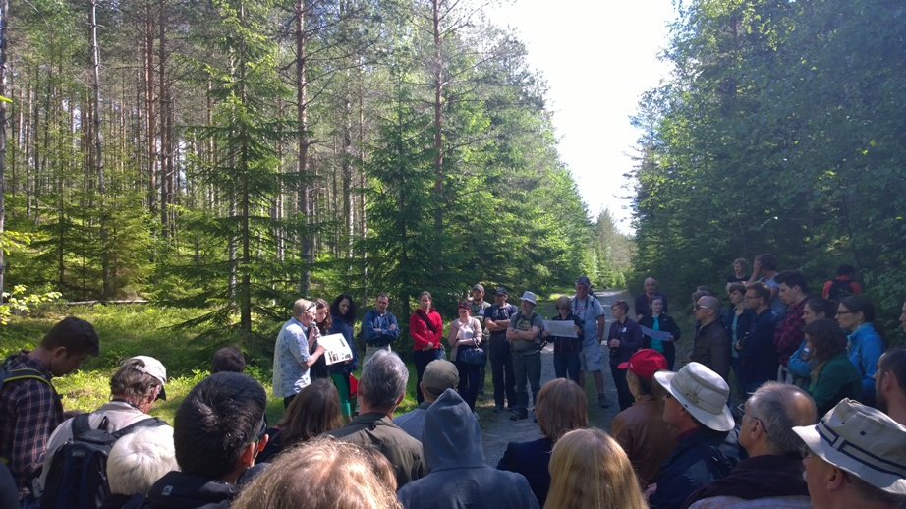
Field trip during the combined conference of Working Parties 7.02.02 (Foliage, shoot and stem diseases
of forest trees) and 7.03.04 (Diseases and insects in forest nurseries) in Uppsala, Sweden.

Within Research Group 7.02, “Pathology”, six meetings were organised since April 2015. A joint meeting of WP7.02.02 (Foliage, shoot and stem diseases of forest trees) and WP7.03.04 (Diseases and insects in forest nurseries) took place in Upsala, Sweden. WP7.02.04 (Phytoplasmas and virus diseases of forest trees) organised a workshop as a satellite meeting to the XVIII International Plant Protection Congress in Berlin, Germany. WP7.02.01 (Root and stem rot of forest trees) met in Antalya, Turkey. Working Party 7.02.11 (Parasitic flowering plants in forests) met in Ashland, Oregon, and proceedings will be published in a special issue of the Journal Botany. Finally, WP 7.02.10 (Pine Wilt Disease) met in Korea. Collectively, there were approximately 300 participants at these meetings, from up to 22 countries. In addition, there was a jointly organised meeting with 7.03.11 (on Genetics of Host-Parasite Interactions in Forestry, see below).

A new Working Party in RG7.02 was founded last year, on “Forest health in southern hemisphere commercial plantations” (WP7.02.13), coordinated by Rebecca Ganley (New Zealand), Rodrigo Ahumada (Chile), Angus Carnegie (Australia) and Carlos Perez (Uruguay). The first meeting of the new Working Party was planned as a session at the Division 7 conference in Istanbul but as this was cancelled, this was postponed to the 125th Anniversary Congress in Freiburg in 2017. Judging by the interest in the planned session and the number of abstracts that were submitted, the new Working Party will be popular in the forest health community.

In Research Group 7.03, “Entomology”, there were six working party conferences since the last board meeting in April 2015, as well as an interdisciplinary “International Workshop on the Genetics of Tree-Parasite Interactions” (in Orléans, France) that was a joint activity of 7.03.11 (Resistance to insects), 7.02.05 (Rusts of forest trees), and two RG2.02 (Conifer breeding and genetic resources) working parties (2.02.15 and 2.02.20). WP7.03.10 (Methodology of forest insect and disease survey in Central Europe) met in San Michele all'Adige, Italy, with 54 delegates from 17 countries, primarily from Europe. A conference on “Population Dynamics and Integrated Control of Forest Defoliating and Other Insects” was held in Sopot, Poland, as a joint meeting of three working parties (7.03.07 “Population Dynamics of Forest Insects”, 7.03.06 “Ecology and Management of Forest Defoliating Insects”, and 7.03.13 “Biological Control of Forest Insects and Pathogens”), with 75 delegates from 23 countries. Finally, a conference on “A Global Perspective on the Ecology and Management of Bark and Wood Boring Insects”, was held in Bariloche, Argentina (as a joint meeting of WP7.03.05 “Ecology and Management of Bark and Wood Boring Insects” and WP7.03.12 “Alien Invasive Species and Global Trade”). There were 68 delegates from 23 countries, with 60% of attendees coming from South America. We are pleased to see the increased activity in Latin America as this is a region where traditionally IUFRO has not had as much participation.
A conference on “Climate-induced range shifts in boreal forest pests and their ecological, economic and social consequences” was co-sponsored by WP7.03.05 “Bark and Wood Boring Insects”, WP7.03.07 “Population Dynamics of Forest Insects” and Division 8 WP 8.01.06. This took place from 11 - 15 July 2016 in Baie-Comeau, Sept-Iles, Quebec, Canada, and it included a large field component to see insect damage in the forest.
A new working 7.03.15, “Social dimensions of forest health” began its mission last year. Mariella Marzano is the founding Coordinator with Robert Haight, Tom Holmes and Carina Keskitalo acting as deputies. We welcome the addition of social dimensions activities to our Division and we look forward to interactions concerning across all research groups and working parties. An initial workshop took place in London, UK, on 30 Aug. 2016.

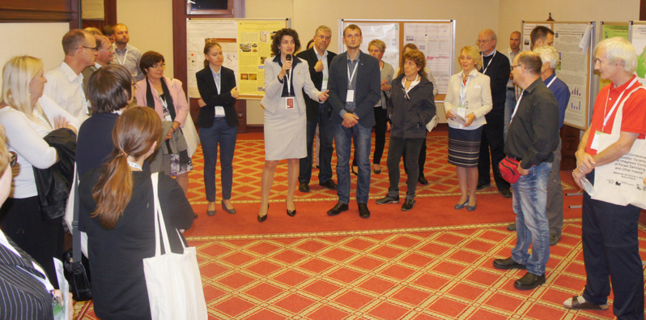
Poster session during the conference “Population dynamics and integrated control of forest defoliating and other insects” (Working Parties 7.03.07, 7.03.06 and 7.03.13) in Sopot, Poland.

Other news from Division 7 and changes in coordinators

We are most grateful for the contributions from conference organisers, working party coordinators and deputies. Several changes in coordinators of Division 7 working parties occurred since April 2015: After many years of service for WP 7.01.02, Rainer Matyssek stepped down as coordinator, with Zhaozhong Feng taking this role for the expanded WP on “Genetic, biochemical and physiological processes”. Alessandra De Marco is taking over from Salim Belyazid as coordinator of 7.01.05 (Modelling and risk assessment). Mikhail Kozlov has taken over from Nancy Grulke as coordinator of 7.01.08 (Multiple stressors) while Deputy Yakira Bahadur has resigned.

Matteo Garbelotto passed on the coordinator role of WP7.02.01 (Root and stem rot of forest trees) to Jonas Ronnberg, with Tuğba Doğmuş Lehtijarvi as deputy. Julio Diez is the new coordinator for WP7.02.02 (Foliage, shoot and stem diseases of forest trees) with Glen Stanosz and Tuğba Doğmuş Lehtijarvi serving as deputies. After two terms, Richard Hamelin resigned as coordinator of WP7.02.05 (Rusts of forest trees); he is succeeded by Pascal Frey. Dave Shaw is the new coordinator of WP7.02.11 (Parasitic flowering plants in forests) with Simon Shamoun and Marcelo Luis Wagner as deputies. Finally, Katsunori Nakamura passed on the leadership of WP 7.02.10, pine wilt disease, Christelle Robinet of INRA, France, with Luis Bonifácio (Portugal), Hyerim Han (Korea) and Katsunori Nakamura (Japan) as deputies.

A number of publications were prepared in conjunction with Division 7 conferences. Research Group 7.01 published two conference proceedings in peer-reviewed journals (see above). Another publication project that has been in the making since the IUFRO World Congress in 2014 appeared as a special issue of the journal ‘Forestry – An International Journal of Forest Research’. The special issue is themed ‘Forest health in a changing world: Effects of globalisation and climate change on forest insect and pathogen impacts’ and it was coordinated by Tod Ramsfield, Barbara Bentz, Massimo Faccoli, Hervé Jactel, and Eckehard Brockerhoff – see http://forestry.oxfordjournals.org/content/89/3.toc or email eckehard.brockerhoff@scionresearch.com. Another highlight was the publication of a paper entitled ‘Planted forest health: The need for a global strategy’ by Mike and Brenda Wingfield, Eckehard Brockerhoff and Bernard Slippers in the journal ‘Science’.

Much effort went into the planning and organisation of the All Division 7 conference which was planned to take place from 25-29 April 2016 in Istanbul, Turkey. It was themed “Global change and forest health” and we did look forward to the interactions with our colleagues across the three research groups. Unfortunately, we had to cancel the conference due to the worsening security situation. Nevertheless, we are most grateful to Yusuf Serengil, the local organiser, who has worked very hard to make the conference possible. The all-Division 7 conference was postponed to September 2017, as an event within the 125th Anniversary Congress in Freiburg, Germany.

Acknowledgements

We would like to thank all Working Party coordinators and deputies and other contributors to Division 7 activities. A special thanks also to our colleagues at IUFRO’s Secretariat in Vienna for their continued support and expert assistance.

Key issues discussed and latest findings in the field

Air pollution and climate change (Research Group 7.01) (by Elena Paoletti, elena.paoletti@cnr.it)

Research directions from the 27th conference for Specialists in Air Pollution and Climate Change Effects on Forest Ecosystems (2015) reflect knowledge advancements about (i) Mechanistic bases of tree responses to multiple climate and pollution stressors, in particular the interaction of ozone (O₃) with nitrogen (N) deposition and drought; (ii) Linking genetic control with physiological whole-tree activity; (iii) Epigenetic responses to climate change and air pollution; (iv) Embedding individual tree performance into the multi-factorial stand-level interaction network; (v) Interactions of biogenic and anthropogenic volatile compounds (molecular, functional and ecological bases); (vi) Estimating the potential for carbon/pollution mitigation and cost effectiveness of urban and peri-urban forests; (vii) Selection of trees adapted to the urban environment; (viii) Trophic, competitive and host/parasite relationships under changing pollution and climate; (ix) Atmosphere–biosphere–pedosphere interactions as affected by anthropospheric changes; (x) Statistical analyses for epidemiological investigations; (xi) Use of monitoring for the validation of models; (xii) Holistic view for linking the climate, carbon, N and O₃ modelling; (xiii) Inclusion of multiple environmental stresses (biotic and abiotic) in critical load determinations; (xiv) Ecological impacts of N deposition in the under-investigated areas; (xv) Empirical models for mechanistic effects at the local scale; (xvi) Broad-scale N and sulphur deposition input and their effects on forest ecosystem services; (xvii) Measurements of dry deposition of N; (xviii) Assessment of evapotranspiration; (xix) Remote sensing assessment of hydrological parameters; and (xx) Forest management for maximizing water provision and overall forest ecosystem services. Ground-level O₃ is still the phytotoxic air pollutant of major concern to forest health. Specific issues about O₃ are: (xxi) Developing dose–response relationships and stomatal O₃ flux parameterizations for risk assessment, especially, in under-investigated regions; (xxii) Defining biologically based O₃ standards for protection thresholds and critical levels; (xxiii) Use of free-air exposure facilities; (xxiv) Assessing O₃ impacts on forest ecosystem services.

Pathology and Entomology (Research Groups 7.02 and 7.03)
(by Andrew “Sandy” Liebhold, aliebhold@fs.fed.us)

The process of researching forest insects to develop improved management is changing rapidly. Methods of sampling, data collection and analysis are improving, partly as a result of improved electronic & computer technology & partly as a result of the broader use of the principles of experimental design.
On the other hand, the context and aims of managing forest insects have become considerably more complex. This is partly due to the broader management aims which typically include more attention to ecological sustainability as well as the traditional goals related to resource extraction.
Both climate change and globalization are making trees more prone to disease. Some parasites like the Woolly poplar aphid (Phloemyzus passerinii) or the Pine processionary moth (Thaumetopoea pityocampa) are expanding their range while some others are invading new continents or new hosts.
Major pest and disease outbreaks such as Dutch elm disease (Ophiostoma novo-ulmi), canker of sycamore (Ceratocystis platani), emerald ash borer (Agrilus planipennis) and European ash dieback (Hymenoscyphus fraxineus) have increased public awareness that some tree species can become extinct or very rare in a small period of time.
The scientific community is urged to provide sustainable long-term strategies for keeping trees healthy, the most straightforward being to select/promote/breed resistant material.
The components of global change are major factors adding to the increasing complexity of managing forest insects. Climate change is shifting the ecological relationships that underpin forest-insect interactions. Land use change has a variety of effects, perhaps the clearest involves the planting of tree species in what turn out to be unfavorable habitats. The stressed trees then succumb more easily to insect attack. This and the increased shipping of goods around the world have provided many potentially invasive insects with opportunities.

Newsletters and list-servers
Division 7 and our Research Groups produce newsletters on a regular basis, usually one or two per year. These can be found on the IUFRO website at the respective Research Group pages under “Publications & References”.
The three list-servers of the Division 7 Research Groups (ForClimAir, ForPath, and ForEnt) continue to enjoy much support from the community. Collectively there are about 1200 subscribers across the 3 list-servers:
- http://www.iufro.org/science/iufro-mailing-lists/list-management/rg-702-forpath/
- http://www.iufro.org/science/iufro-mailing-lists/list-management/rg-701-forclimair/
- http://lists.iufro.org/mailman/listinfo/rg70300-forent
There is also a Div. 7 list-server, http://www.iufro.org/science/iufro-mailing-lists/list-management/div-7-list/

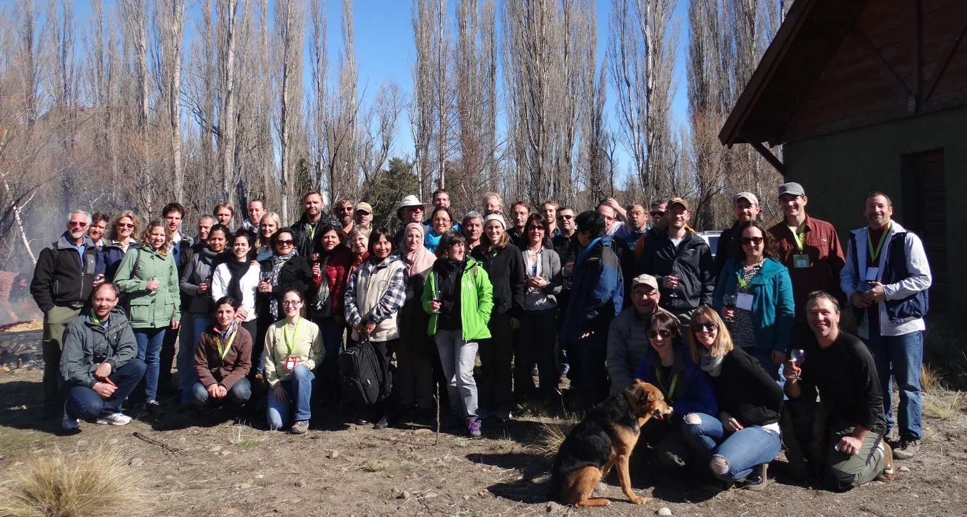
Field trip during the joint meeting of Working Parties 7.03.05 (Ecology and Management of Bark and
Wood Boring Insects) and 7.03.12 (Alien Invasive Species and International Trade).

Upcoming Division 7 conferences and meetings

22-23 October 2016, Beijing, China: WP7.01.02, Second Asia Air Pollution Workshop. Contact: Zhaozhong Feng, fzz@rcees.ac.cn

24-27 October 2016, Beijing, China: IUFRO Regional Congress for Asia and Oceania (including sessions organised by Division 7 Research Groups and Working Parties). Contact: Shirong Liu, liusr@caf.ac.cn
Division 7 is organising a number of sessions. Congress website: http://www.iufro-ao2016.org/

19-25 March 2017, Sapa, Vietnam: WP7.02.09, Phytophthora in Forests and Natural Ecosystems. Contact: Giles Hardy, G.Hardy@murdoch.edu.au

7-11 May 2017, Niagara Falls, Ontario, Canada: WP7.02.02, Foliage, Shoot and Stem Diseases of Forest Trees.
Contact: Tod Ramsfield, Tod.Ramsfield@canada.ca

11-15 September 2017, Thessaloniki, Greece: Joint meeting of WP7.03.05 (Ecology and management of bark and wood boring insects) and WP7.03.10 (Methodology of forest insect and disease survey). Contact: Dimitrios Avtzis, info@iufrogreece2017.com

19-22 September 2017, Freiburg, Germany: IUFRO 125th Anniversary congress. IUFRO – 125th Anniversary Congress 2017. An all-Division 7 meeting is taking place within this congress. For more information visit the congress website: http://iufro2017.com/

Please contact us if we are not aware of any other upcoming meetings (that are not listed above). That will enable us to assist with getting them advertised on the IUFRO website and in our newsletters. Thanks!

Division 7 meetings and conferences in 2015-2016

1-5 June 2015, Nice, France: Biennial Research Group 7.01.00 meeting "Global challenges of air pollution and climate change to forests." Contact: Pierre Sicard, Pierre.Sicard@acri-st.fr, Elena Paoletti, elena.paoletti@cnr.it

7-12 June 2015, Uppsala, Sweden: Joint Working Party 7.02.02 “Foliage, shoot and stem diseases of forest trees” and WP 7.03.04 “Diseases and insects in forest nurseries” Meeting. Organisers: Jonàs Oliva (jonas.oliva@slu.se), Jan Stenlid (jan.stenlid@slu.se), Rimvys Vasaitis (rimvys.vasaitis@slu.se)
Conference report: http://www.iufro.org/download/file/20983/2749/uppsala15-report_pdf/

22-26 June, 2015, San Michele All'adige, Italy: "Fluctuation of Insect and Diseases" Working Party 7.03.10, Methodology of forest insect and disease survey in Central Europe. Contacts: Giorgio Maresi (giorgio.maresi@fmach.it), Cristina Salvadori (cristina.salvadori@fmach.it), Erica Candioli (erica.candioli@fmach.it), Miloš Knížek (knizek@vulhm.cz, Wojciech Grodzki (W.Grodzki@ibles.waw.pl)
Conference homepage: http://eventi.fmach.it/IUFRO
Conference report: http://www.iufro.org/download/file/22948/2622/sanmichele15-report_doc/

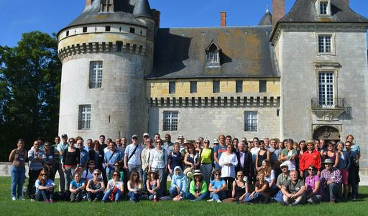
Participants of the “Fifth International Workshop on the Genetics of Tree-Parasite Interactions” in Orléans, France (Working Parties 7.02.05 “Rusts of forest trees”, 7.03.11 “Resistance to insects”, 2.02.15 “Breeding and genetic resources of five-needle pines”, & 2.02.20 “Breeding and genetic resources of southern pines”)

23-28 August 2015, Orléans, France: “Fifth International Workshop on the Genetics of Host-Parasite Interactions in Forestry: Novel challenges and opportunities for resistance to pests and pathogens”, Working Parties 2.02.15 (Breeding and genetic resources of five-needle pines), 2.02.20 (Breeding and genetic resources of southern pines), 7.03.11 (Resistance to insects) and 7.02.05 (Rusts of forest trees). Contact: Arnaud Dowkiw (Arnaud.dowkiw@orleans.inra.fr), Aurélien Sallé (aurelien.salle@univ-orleans.fr), Véronique Jorge (veronique.jorge@orleans.inra.fr). Conference website: https://colloque.inra.fr/tree-parasite-interactions2015

25 August 2015, Berlin, Germany: Working Party 7.02.04 “Phytoplasmas and virus diseases of forest trees” (A satellite meeting of the XVIII International Plant Protection Congress). Contact: Carmen Büttner, carmen.buettner@agrar.hu-berlin.de, Report: http://www.iufro.org/download/file/21842/2737/berlin15-report_pdf/

1-4 September, 2015, Bariloche, Argentina: “Bark and Wood Boring Insects: a global perspective on their ecology and management” Working Party 7.03.05 “Bark and Wood Boring Insects”. Contact: Juan C. Corley (elmallin@gmail.com), Conference website: https://sites.google.com/site/iufrobariloche2015/

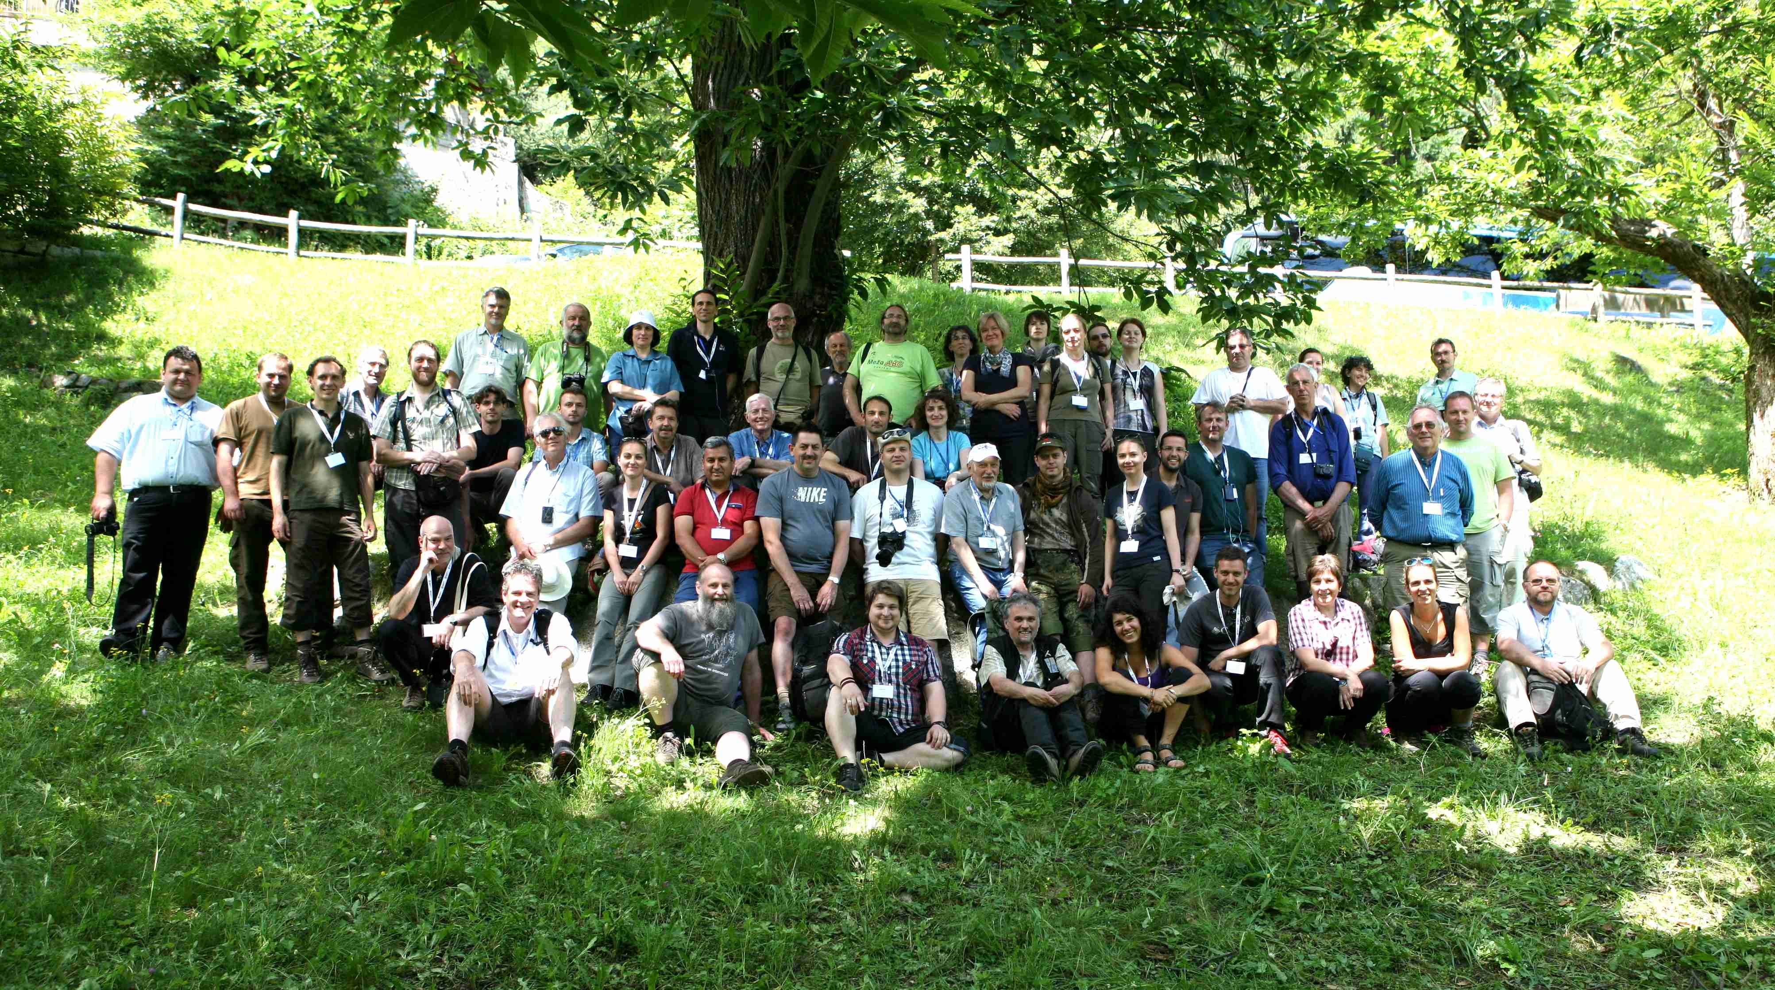
Working Party 7.03.10 “Methodology of forest insect and disease survey in Central Europe” meeting
in San Michele All'adige, Italy.

28 September - 2 October, 2015, Sopot, Poland: Working Parties 7.03.07 "Population Dynamics of Forest Insects", 7.03.06 "Integrated management of forest defoliating insects", 7.03.13, "Biological control of forest insects and pathogens". Contact: Lidia Sukovata, iufro.poland@gmail.com
Conference website: http://www.ibles.pl/web/iufro/about
Report: http://www.iufro.org/download/file/22136/2646/sopot15-report_doc/

12-18 October 2015, Antalya, Turkey: Working Party 7.02.01 “Root and Butt Rot”. Contact: H. Tuğba Doğmuş Lehtijarvi, email: tugba@orman.sdu.edu.tr, Conference website: http://ormanweb.sdu.edu.tr/iufro2015/

In addition, Research Group 7.01 contributed to the European Geosciences Union General Assembly 2015: ERE3.7/SSS11.7 “Sustainable biomass for raw materials, energy and GHG mitigation” 16 April 2015, Vienna, Austria via Working Party 7.01.03 and the IUFRO Task Force "Sustainable Forest Biomass Network"

27 – 29 June 2016, Cracow, Poland: Working Party 7.01.08 in collaboration with WG 3.02.00. Second Scientific Conference on Reforestation Challenges: "Opportunities for sustainable development in a degraded forestry environment". Contact: Stanisław Małek, rlmalek@cyf-kr.edu.pl Website: http://reforestationchallenges.pl/

11 - 15 July 2016, Baie-Comeau, Sept-Iles, Quebec, Canada: Climate-Induced range shifts in boreal forest pests and their ecological, economic and social consequences. Working Parties 8.01.06, 7.03.05 “Bark and Wood Boring Insects”, and 7.03.07 “Population Dynamics of Forest Insects”. Contact: Pierre Godbout, pierre.godbout@canada.ca Website: http://www.cef-cfr.ca/index.php?n=Colloque.IUFROQuebec2016

17-22 July 2016, Ashland, Oregon, USA: Working Party 7.02.11 “Parasitic flowering plants in forests” is hosting a global meeting on "Mistletoes: Pathogens, keystone resource, and medicinal wonder". Contacts: brianna.beene@oregonstate.edu and dave.shaw@oregonstate.edu
Conference website: http://blogs.oregonstate.edu/mistletoe/

29 August - 2 September 2016, Seoul, South Korea: Working Party 7.02.10, Pine Wilt Disease Conference 2016, Contact: Katsunori Nakamura, knakam@affrc.go.jp Website: http://www.pinewiltdisease2016.or.kr

30 August 2016, London, UK, Working Party 7.03.15 “Social dimensions of forest health” workshop on “Human Dimensions of Tree Health & Plant Biosecurity: International Perspective”. Contact: Mariella Marzano, mariella.marzano@forestry.gsi.gov.uk

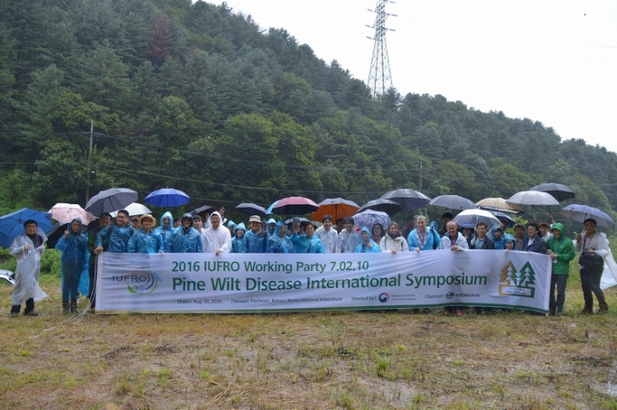
Working Party 7.02.10, Pine wilt disease international symposium, 29 Aug. - 2 Sep. 2016, Seoul, South Korea.

