Update from the International Union of Forest Research Organizations Forest Pathology Research Group
Submitted by Tod Ramsfield, 25 July 2018.
In 2017, Jolanda Roux stepped down from her roles of leader of IUFRO forest pathology Research Group 7.02 and leader of the ICPP forest pathology Subject Matter Committee (SMC). As deputy of the Research Group, Tod Ramsfield stepped into the role of Research Group leader and Rebecca Ganley of Scion, New Zealand and Julio Javier Diez Casero of the University of Valladolid, Spain, joined the IUFRO forest pathology Research Group leadership team. Jolanda intended to link the IUFRO pathology Research Group with the activities of the ICPP forest pathology SMC, the following report has been prepared in order to outline the activities of the IUFRO forest pathology Research Group. The position of Chairperson of the ICPP forest pathology SMC is currently vacant and will be filled shortly through a selection process. This report has been prepared to highlight the activities of the IUFRO forest pathology Research Group and to reaffirm our commitment to the ICPP forest pathology SMC.
The Research Group has maintained a high level of activity between the ICPP meetings of 2013 and 2018 with significant participation in three large events as well as several smaller Working Party meetings. The three large events that occurred were the 2014 XXIV IUFRO World Congress in Salt Lake City, USA, from 5-11 October 2014, the IUFRO Regional Congress for Asia and Oceania in Beijing, China, from 24-27 October 2016, and the IUFRO 125 Year Anniversary Congress in Freiburg, Germany, from 18-22 September 2017. All of these congresses included strong participation from the forest pathology research group and each included sessions that were focussed on different aspects of forest pathology, which were often integrated other aspects of forest health, such as forest health in a changing climate. These were large meetings, with attendance ranging from approximately 1,200 to 2,400 scientists at each event, representing all IUFRO divisions. These meetings provided excellent opportunities for international networking across disciplines.
In addition to the large congresses, several Working Parties held meetings between 2013 and 2018. The Working Parties are highly focussed in their activities, typically bringing together 40 – 100 scientists for discussions centred on specific forest pathology topics and they vary in their frequency depending on the group. The meetings always include a field trip to observe forest pathology issues within the host country and the content of their meetings are captured in proceedings volumes or special issues of journals. Working Parties continue to be established, with the most recent being 7.02.13 “Forest Health in Southern Hemisphere Commercial Plantations” which held its inaugural meeting in Punta de Este, Uruguay, in March of 2018. The full list of Working Party meetings that occurred is as follows:
- 7.02.09 “Phytophthora Diseases on Forest Trees”, 7th Meeting, Esquel, Patagonia, Argentina, 2014-11-10 to 2014-11-14.
- Joint meeting of 7.02.02 “Foliage, Shoot and Stem Diseases” and 7.03.04 “Diseases and insects in forest nurseries”, Uppsala, Sweden, 2015-06-07 to 2015-06-12.
- 7.02.04 “Phytoplasma and Virus Diseases of Forest Trees” workshop in association with the International Plant Protection Congress, Berlin, Germany, 2015-08-25.
- 7.02.11 “Parasitic Flowering Plants in Forests”, Ashland, Oregon, USA, 2016-07-12 to 2016-07-22.
- 7.02.10 “Pine Wilt Disease”, Seoul, South Korea, 2016-08-29 to 2016-09-02
- 7.02.09 “Phytophthora Diseases on Forest Trees”, 8th Meeting, Sapa, Vietnam, 2017-03-19 to 2017-03-25.
- 7.02.02 “Foliage, Shoot and Stem Diseases”, Niagara Falls, Ontario, Canada, 2017-05-07 to 2017-05-11.
- 7.02.13 “Forest Health in Southern Hemisphere Commercial Plantations”, Punta del Este, Uruguay, 2018-03-21 to 2018-03-21.
Communication is an important component of maintaining continuity between Working Party meetings and the larger events and this is facilitated through multiple moderated list servers. Upcoming meetings, general queries, and student and employment opportunities are among topics that are circulated via these list servers. Several lists are available and the primary list of interest to forest pathologists is FORPATH. Anyone with an interest in forest health is encouraged to subscribe to the list servers through the IUFRO website (https://www.iufro.org/science/iufro-mailing-lists/list-management/). The Research Group newsletter is also produced and it includes meeting summaries, upcoming events and other issues of importance to the forest pathology community. The newsletter archive can be accessed here: https://www.iufro.org/science/divisions/division-7/70000/70200/publications/
In the near future, several working parties will be meeting: Working Party 7.02.01, Root and Butt Rots, will be meeting in Sweden in August, 2018; Working Party 7.02.02 and 7.02.03 are planning to meet in Florence, Italy in March of 2019; and Working Party 7.02.09 will be meeting in Sardinia, Italy in late October 2019. The upcoming XXV World Congress will be held in Curitiba, Brazil, from 29 September – 5 October, 2019 and several session proposals are currently being prepared to ensure strong forest pathology content at the World Congress. Session proposals are due 1 August 2018 and must be submitted through the World Congress website (iufro2019).
The forest pathology Research Group within Division 7 of IUFRO welcomes participation from all forest pathologists and is committed to a global exchange of ideas in a respectful and open environment where the common objective is maintaining healthy forests for the benefit of all.

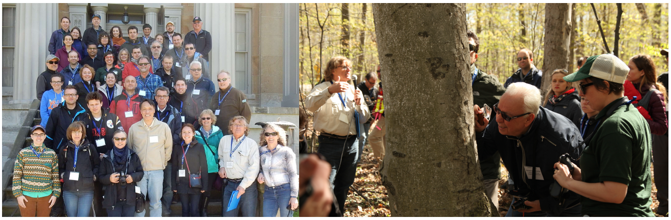
Participants and the investigation of beech bark disease during the field tour that took place during the meeting of Working Party 7.02.02 in Niagara Falls, Ontario, 7-11 May 2017. Photos courtesy of Tom Hsiang (L) and Miloň Dvořák (R).

