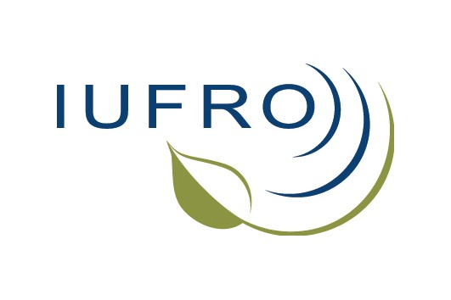

First International Symposium of IUFRO Working Party 9.05.03
Cross-sectoral policy impacts on forests and environment

Hollywood Hotel, Sarajevo, Bosnia-Herzegovina, November 28th - 29th, 2013

Due to emerging cross-sectoral policy impacts on forests and environment it is obvious that forestry sector alone cannot achieve sustainable forest management. Policies in related areas such as agriculture, energy, climate changes, biodiversity, water and tourism are heavily affecting framework conditions for forest and environment. At the same time, global trends such as increased demand for energy and raw materials, globalization, trade liberalization and the diversification of demand for forest goods and services, have enhanced reciprocal reflections - the goods and services from trees and forests become more and more important and demanded by other sectors.

With the aim to focus on the relations, linkages and interdependencies of changes in forest land use but also to contribute to international scientific dialogue on how to engage with other sectors so as to better coordinate and harmonize policies, especially in areas of conflicting priorities, IUFRO Working Party 9.05.03 Cross-sectoral policy impacts on forests and environment has been established in 2012.

The first international Symposium of Working Party 9.05.03 will be organized in Sarajevo (Bosnia-Herzegovina), November 28th – 29th, 2013, gathering scientists interested in cross-sectoral policy impacts on forests and environment. The thematic topic of this event will be focused on perception of professionals from different sectors towards forest governance in the Western Balkans. It is expected this event will contribute to cross-disciplinary research in forestry and environmental sciences as well as to strengthen the importance of policy and social sciences in IUFRO.

There are no registration fees for this Symposium and participants are expected to book their accommodation directly with the Hotel Hollywood (http://www.hotel-hollywood.com.ba/). It provides an excellent conference venue with high quality conference rooms and facilities, excellent accommodation, and all meals during the Symposium. The special price was negotiated (30 Euro per person/night in double room with three meals included) for participants. For online booking please refer to IUFRO Symposium. The Sarajevo Airport is only 10 minutes away and so transportation is easily arranged. The city of Sarajevo is easily accessible by tram or taxi for those wanting to explore its historic down town.

For the organizational purposes please complete and return registration form (do not forget to book your accommodation by yourself directly with the hotel administration) to Mersudin Avdibegović (mavdibegovic@gmail.com) and Bruno Marić (bruno.m.maric@gmail.com) by November 20th, 2013 the latest.

REGISTRATION FORM

Last name: |  |  |  | First name:
Organization:
Address:
City: |  |  |  | Postal/Zip code:
Country: |  |  |  | Phone:
Fax: |  |  |  | E-mail:
I plan to travel by: plane bus train other …………………............... (please specify)

and arrive at (please specify airport/station) ………………………………………………………..
Travel arrangements | Arrival  date: | Time: | Flight No: |  | Departure  date: | Time: | Flight No:
I will provide a paper
yes
Title of paper …...............................................................................................................................

no
Comments, proposals, limitations:

