 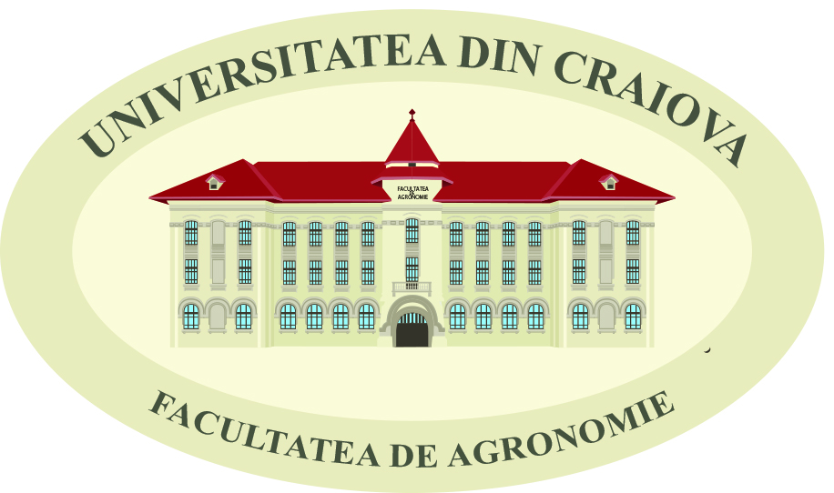  

**The 15th ANNUAL MEETING**

"**DURABLE AGRICULTURE –AGRICULTURE OF THE FUTURE"**

**REGISTRATION FORM**

**1. Paper title:**

Click here to enter text.

**2. Abstract (maximum half page):**

Click here to enter text.

**3. Type of presentation:** Choose an item.

**4. Working Group** (Working Group 1:Plant cultivation and animal growing technologies; Working Group 2:Soil Sciences; Working Group 3:Fundamentally Disciplines and Environment and Plant Management; Working Group 4:Management, agriculture mechanization and cadastre)

Click here to enter text.

**The name of the first author:** Click here to enter text.

**E-mail address:** Click here to enter text.

**Affiliation (Institution Name, Addresss, Postal code,Town, Country, E-mail, Phone, and *VAT number)*:** Click here to enter text.

**Tourist visit:** Choose an item.

**The name of the second author:** Click here to enter text.

**Affiliation (Institution Name, Addresss, Postal code,Town, Country, E-mail, Phone, and *VAT number)*:**Click here to enter text.

**Tourist visit:** Choose an item.

**The name of the third author:** Click here to enter text.

**Affiliation (Institution Name, Addresss, Postal code,Town, Country, E-mail, Phone, and *VAT number)*:**Click here to enter text.

**Tourist visit:** Choose an item.

**Many authors:**  If there are more than 3 authors, please fill in here)

Click here to enter text.

Please return this form by 25th October 2016 to the meeting scientific secretary:

e-mail address: agronomie_cv@yahoo.com

Phone: +40-251-41 84 75, Fax: +40-251-41 84 75