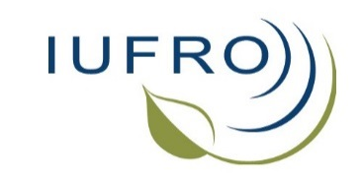

2016-2017 Report and news (September 2017)

Compiled by Ecki Brockerhoff (Coordinator Division 7) Eckehard.Brockerhoff(a)scionresearch.com, Elena Paoletti (Coordinator RG 7.01 “Air Pollution and Climate Change”), Tod Ramsfield (RG 7.02 “Pathology”), and Andrew (“Sandy”) Liebhold (RG 7.03 “Entomology”)

Table of Contents
A note about Jolanda Roux who has resigned as coordinator of Research Group 7.02 (Pathology), and changes in the leadership of the Research Group 1
All-Division 7 (Forest Health) conference plans and changes 2
News from our Research Groups and Working Parties 2
Newsletters and list-servers 8
Acknowledgements 8
Changes of coordinators and deputies in Division 7 8

A note about Jolanda Roux who has resigned as coordinator of Research Group 7.02 (Pathology), and changes in the leadership of the Research Group

After serving as coordinator of Research Group 7.02 Pathology since 2010, Jolanda Roux has recently resigned from her role. During her time as Research Group coordinator, Jolanda facilitated many IUFRO pathology conferences as well as contributions to IUFRO congresses. In addition, Jolanda has been a committed advocate of fostering involvement and participation of researchers and students from Africa and other regions that are less well represented in IUFRO. She also oversaw changes in the leadership of working parties 7.02.01, 7.02.02, 7.02.06, 7.02.09, 7.02.10 and 7.02.11. Jolanda was also instrumental in the establishment of the new working party 7.02.13 “Forest Health in Southern Hemisphere Commercial Plantations”. Jolanda was recognized for her scientific achievements during the IUFRO World Congress in 2014 and she also received the Queen’s Award for Forestry in 2011. Jolanda had a large impact on the research group and we will miss her input.

The IUFRO Board has approved that deputy Tod Ramsfield will take over the coordinator role of RG 7.02. Beccy Ganley, Coordinator of Working Party 7.02.13 – Forest health in southern hemisphere commercial plantations, and Julio Diez Casero, Coordinator of Working Party 7.02.02 – Foliage, shoot and stem diseases, have agreed to serve as the new deputies. Tod, Beccy and Julio will serve in these roles until the end of the present term which concludes during the 2019 World Congress, although their appointments can be extended.

We would like to take this opportunity to thank Jolanda for her leadership and all of the work that she has done for IUFRO and our forest pathology community. We look forward to interacting with her in the future.

Ecki, Tod, Beccy and Julio

All-Division 7 (Forest Health) conference plans and changes

In 2016, much effort went into the planning and organisation of the All-Division 7 conference that was planned to take place from 25-29 April 2016 in Istanbul, Turkey. Unfortunately, we had to postpone and relocate the conference due to concerns about the security situation and cancellations of numerous participants. Nevertheless, we are most grateful to Yusuf Serengil (Coordinator or Working Party 7.01.08), the local organiser, who worked very hard to make the conference possible. We tried our best to proceed with the conference in Istanbul but unfortunately, this was not possible. In consultation with the Division 7 Research Group and Working Party coordinators, it was decided to hold the postponed all-Division 7 conference as an event within the 125th Anniversary Congress in Freiburg, Germany, in September 2017.

News from our Research Groups and Working Parties

Research Group 7.01, Effects of air pollution and climate change on forest health
Coordinator and deputies: Elena Paoletti, Andrzej Bytnerowicz, and He Shang

As usual, Research Group (RG) 7.01 has been very active in the last 18 months. A list of recent 7.01 meetings and meeting participations is given below. Officers of RG 7.01 organised five sessions at the IUFRO regional Asia Oceania congress in Beijing (October 2016) as well as six sessions at the 125th Anniversary congress in Freiburg (September 2017): Session 190 (Climate change and forest health: insights from the IUFRO Task Force), 161 (Combined and interactive effects of multiple stressors on forest health), 56 (Modern approaches in evaluating ozone impacts on forests), 136 (Hierarchical modelling framework to quantify and forecast climate change and air pollution impacts on forest ecosystems), 146 (Climate change and air pollution impacts on forest health status and productivity) and 191 (Nitrogen deposition: spatial-temporal change and ecological impacts).

Several changes in coordinators of RG 7.01 working parties occurred (see the list below). Two new WPs were approved at the D7 meeting in Beijing (IUFRO regional Asia-Oceania conference in 2016) and were established in 2017, with old and new officers: WP 7.01.09 - Ground-level ozone, and WP 7.01.10 - Nitrogen and sulfur deposition.

A newsletter is regularly circulated by the mailing list, see www.iufro.org/science/iufro-mailing-lists/list-management/rg-701-forclimair/ and there is also social media activity. A Facebook group was launched in 2015 and at present it has 128 members, see www.facebook.com/groups/959912024041551/?fref=ts

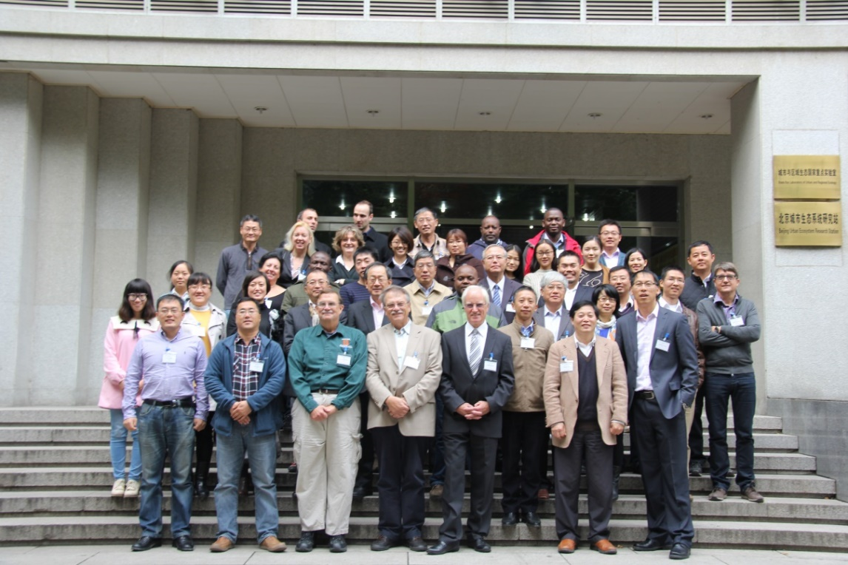
Participants of the “Second Asia Air Pollution Workshop” (Working Party 7.01.02),
in Beijing, China, October 2016

Past meetings of RG 7.01 (since mid-2016)

22-23 October 2016, Beijing, China: Working Party 7.01.02, Second Asia Air Pollution Workshop. Contact: Zhaozhong Feng, fzz(a)rcees.ac.cn

24-27 October 2016, Beijing, China: IUFRO Regional Congress for Asia and Oceania (5 sessions). Contact: Elena Paoletti, elena.paoletti(a)cnr.it

24 April 2017, Vienna, Austria: T30 ERE3.6: The role of biomass in a sustainable bio-economy: implications for land use, climate and environmental services. Contact: Viktor Bruckman, viktor.bruckman(a)oeaw.ac.at

Upcoming meetings of RG 7.01

19-22 September 2017, Freiburg, Germany: 6 sessions at the IUFRO 125th Anniversary congress. Contact: Elena Paoletti, elena.paoletti(a)cnr.it

22-26 October 2017, Fuchu, Tokyo, Japan: 28th IUFRO conference for Specialists in Air Pollution and Climate Change Impacts on Forest Ecosystems: "Actions for Sustainable Forest Ecosystems under Air Pollution and Climate Change". Contact: Makoto Watanabe, iufro.tokyo2017(a)gmail.com

21-25 May 2018, Florence, Italy: International Conference on Ozone and Plant Ecosystems. Participation of WPs 7.01.00, 7.01.02, 7.01.05, 7.01.09. Contact: Elena Paoletti, elena.paoletti(a)cnr.it

Please contact us if we are not aware of any other upcoming meetings (that are not listed above). That will enable us to assist with getting them advertised on the IUFRO website and in our newsletters. Thanks!

Research Group 7.02, Pathology
Coordinator and deputies: Tod Ramsfield, Beccy Ganley, and Julio Javier Diez Casero

Despite the postponement of the All-Division 7 conference, where the Pathology Research Group had planned numerous contributions, there were still four successful conferences since last July (listed below), as well as several contributed sessions at the regional congress in Beijing last October.

There were a number of changes in the leadership of RG 7.02. After many years of service as coordinator of the research group, Jolanda Roux stepped down and Tod Ramsfield, the former deputy, took over as coordinator. Please note the separate section on Jolanda at the beginning of this newsletter (see above). In addition, Rebecca (Beccy) Ganley and Julio Diez Casero were appointed as research group deputies. Beccy is leader of WP7.02.13 and Julio is leader of WP 7.02.02.

At least five meetings of pathology working parties are planned in the next three years (see the list below), and a number of sessions organised by the research group will take place at the 125th Anniversary Congress in September 2017.

Tod Ramsfield produced a newsletters of RG 7.02 in December 2016, and another newsletter is planned to be shared via the ForPath listserver soon after the 125th Anniversary Congress in Freiburg. This newsletter will have more information and news about the pathology research group.

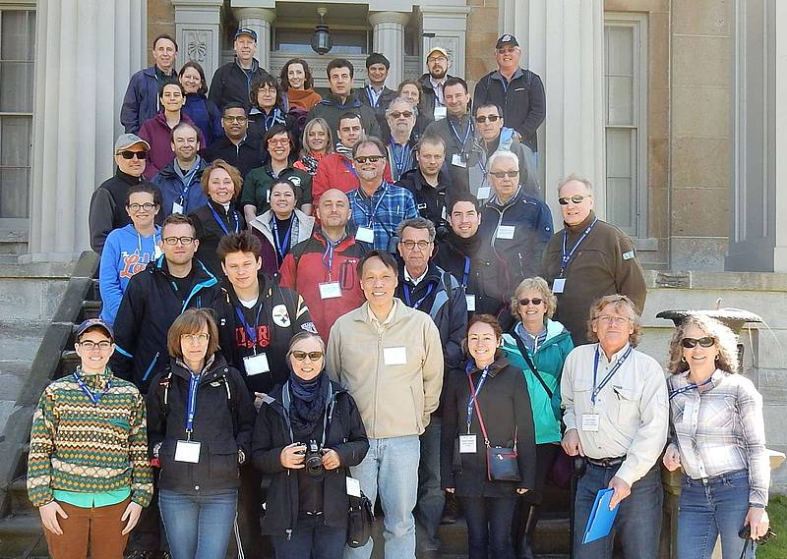
Participants of the meeting of Working Party 7.02.02 “Foliage, Shoot and Stem Diseases of Forest Trees”, Niagara Falls, Ontario, Canada, May 2017.

Past meetings of RG 7.02 (since mid-2016)

17-22 July 2016, Ashland, Oregon, USA: "Mistletoes: Pathogens, keystone resource, and medicinal wonder". Working Party 7.02.11 - Parasitic flowering plants in forests. http://blogs.oregonstate.edu/mistletoe/ Contacts: brianna.beene(a)oregonstate.edu, dave.shaw(a)oregonstate.edu

29 August - 2 September 2016, Seoul, South Korea: “Pine Wilt Disease Conference 2016”. WP 7.02.10 - Pine wilt disease. http://www.pinewiltdisease2016.or.kr Contact: Katsunori Nakamura, knakam(a)affrc.go.jp

24-27 October 2016, Beijing, China: IUFRO Regional Congress for Asia and Oceania (several sessions).

19-25 March 2017, Sapa, Vietnam: Meeting of WP 7.02.09 - Phytophthora in Forests and Natural Ecosystems. Contact: Giles Hardy, G.Hardy(a)murdoch.edu.au

7-11 May 2017, Niagara Falls, Ontario, Canada: Meeting of WP 7.02.02 - Foliage, Shoot and Stem Diseases of Forest Trees. Contact: Tod Ramsfield, Tod.Ramsfield(a)canada.ca

Upcoming meetings of RG 7.02:

19-22 September 2017, Freiburg, Germany: Sessions at the 125th Anniversary Congress,
Session 300 “Pine pitch canker - strategies for management of Gibberella circinata in greenhouses and forests (PINESTRENGTH)” 7.02.02 - Foliage, Shoot and Stem Diseases of Forest Trees
Session PS-170 “Understanding viruses in trees – promoting healthy plants in forest and urban open space.” 7.02.04 - Phytoplasma and virus diseases of forest trees
Session 305 “Pine wilt disease: progress in understanding the dynamics and developing control measures” WP 7.02.10 - Pine wilt disease

21-23 March 2018, Punta del Este, Uruguay: "Improving forest health on commercial plantations”, First meeting of WP 7.02.13 - Forest Health in Southern Hemisphere commercial plantations. March, 2018. www.iufro2018puntadeleste.org. Contact: Gustavo Balmelli, gbalmelli(a)tb.inia.org.uy, and Beccy Ganley, beccy.ganley(a)scionresearch.com

Mid-2018 (date and location to be determined): Viruses contribute to tree decline – experience and future concern. Workshop in summer 2018, WP 7.02.04 - Phytoplasma and virus diseases of forest trees
Contact: Carmen Büttner, carmen.buettner(a)agrar.hu-berlin.de

May 2019, Tuscany, Italy: Meeting of WP 7.02.02 Foliage, Shoot and Stem Diseases of Forest Trees. Contact: Giles Hardy, G.Hardy(at)murdoch.edu.au

2019 (date to be determined), Sardinia, Italy: 9th Meeting of WP 7.02.09 - Phytophthora in forests and natural ecosystems. Hosted by Dr. Bruno Scanu – University of Sassari

2019 (date to be determined), Orléans, France: Pine wilt disease conference, 7.02.10 - Pine wilt disease

Please contact us if we are not aware of any other upcoming meetings (that are not listed above). That will enable us to assist with getting them advertised on the IUFRO website and in our newsletters. Thanks!

Research Group 7.03, Entomology
Coordinator and deputies: Andrew (‘Sandy’) Liebhold, Barbara Bentz, and Hervé Jactel

Three meetings of the Entomology Research Group were held since last July, in addition to several sessions at the Regional IUFRO Congress in Beijing in October 2016. At least six meetings are planned for the next few years (see the list below). The entomology research group is also well represented with several sessions at the upcoming All-Division 7 conference at the IUFRO 125th Anniversary Congress.

A number of changes of coordinators and deputies have occurred, and these are indicated in the list below.
Sandy Liebhold is planning the publication of a research group newsletter, and this will contain more news and other information about past and upcoming meetings and other matters relevant to the research group.

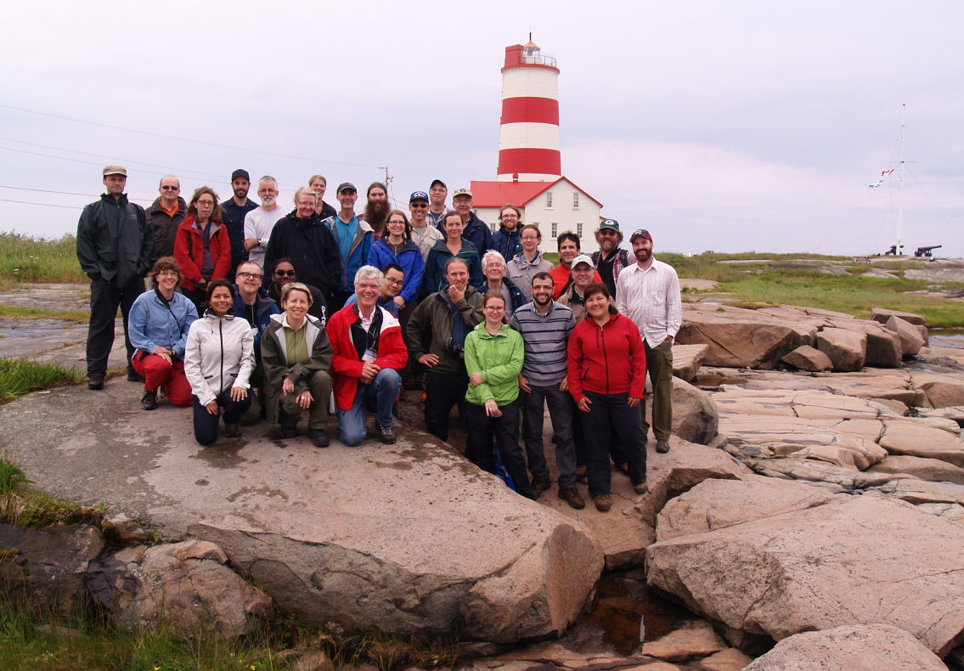
Participants of the IUFRO meeting on “Climate-induced range shifts in boreal forest pests and their ecological consequences”, July 2016, Québec, Canada (Working Parties 7.03.05 “Bark and Wood Boring Insects”,
7.03.07 “Population Dynamics of Forest Insects” and 8.01.06)

Past meetings of RG 7.03 (since mid-2016)

11 - 15 July 2016, Baie-Comeau, Sept-Iles, Quebec, Canada: “Climate-Induced range shifts in boreal forest pests and their ecological, economic and social consequences”. Working Parties 7.03.05 “Bark and Wood Boring Insects”, 7.03.07 “Population Dynamics of Forest Insects” and 8.01.06. Contact: Pierre Godbout, pierre.godbout(a)canada.ca Website: https://tinyurl.com/IUFROquebec2016

30 August 2016, London, UK: “Human Dimensions of Tree Health & Plant Biosecurity Workshop: International Perspective”, 7.03.15 “Social dimensions of forest health” http://www.iufro.org/download/file/26139/5652/london16-report_doc Contact: Mariella Marzano, mariella.marzano(a)forestry.gsi.gov.uk

24-27 October 2016, Beijing, China: IUFRO Regional Congress for Asia and Oceania (several sessions).

11-15 Sept. 2017, Thessaloniki, Greece: “Forest Insects and Pathogens in a Changing Environment: Ecology, Monitoring & Genetics”, Joint 7.03.05 “Ecology and management of bark and wood boring insects” and 7.03.10 “Methodology of forest insect and disease survey “,http://www.iufrogreece2017.com Contact: Dimitrios Avtzis, dimitrios.avtzis(a)gmail.com

Upcoming meetings of RG 7.03:
18-22 Sept. 2017, Freiburg, Germany
Session 57, “Invasive Alien Species and International Trade - Detection Prior to Introduction, Measures and Policy for Mitigation”, WP 7.03.12 – “Alien Invasive Species and International Trade”. Contact: Rene Eschen, R.Eschen(a)cabi.org
Session 199, “Effects of global change on Mediterranean forest insects and interactions with pathogens” WP 7.03.14 - Entomological research in Mediterranean forest ecosystems. Contact: Timothy Paine, timothy.paine(a)ucr.edu
Session 208, “Social and Economic dimensions of forest health: Contributing to a biosecure future”. WP 7.03.15 - Social dimensions of forest health. Contact: Mariella Marzano, mariella.marzano(a)forestry.gsi.gov.uk

August 5-10, 2018, Mt. Sterling, Ohio USA: “Tree resistance to insects and diseases: putting promises into practice”, WP 7.03.11 “Resistance to Insects and Pathogens” jointly with 2.02.15 “Breeding and genetic resources of five-needle pines” and Task Force on Biological Invasions, https://treeresistance2018.ca.uky.edu. Contact: Caterina Villari, cvillari(a)uga.edu

Autumn 2018 (date to be determined), Izmir, Turkey: 7.03.04 Diseases and insects in forest nurseries. Contact: Audrius Menkis, audrius.menkis(a)slu.se

2018 (date to be determined), California: Joint meeting of WP 7.03.14 - Entomological research in Mediterranean forest ecosystems and 7.03.06 “Ecology and management of forest defoliating insects”. Contact: Timothy Paine, timothy.paine(a)ucr.edu

Apil/May 2019 (date to be confirmed), South Africa: WP 7.03.13 - Biological control of forest insects and pathogens (possibly jointly with WP 7.03.07). Contact: Brett Hurley, brett.hurley(at)fabi.up.ac.za

September 2019, Suceava, Romania: WP 7.03.10 - Methodology of forest insect and disease survey. Contact: Mihai-Leonard Duduman, Stefan cel Mare University of Suceava, Forestry Faculty, Applied Ecology Laboratory

2020 (date to be confirmed), Krasnoyarsk, Russia: WP 7.03.07 - Population Dynamics of Forest Insects. Contact: Natalia Kirichenko, nkirichenko(at)yahoo.com

Please contact us if we are not aware of any other upcoming meetings (that are not listed above). That will enable us to assist with getting them advertised on the IUFRO website and in our newsletters. Thanks!

Newsletters and list-servers
Division 7 and our Research Groups produce newsletters on a regular basis, usually one or two per year. These can be found on the IUFRO website at the respective Research Group pages under “Publications & References”.
The three list-servers of the Division 7 Research Groups (ForClimAir, ForPath, and ForEnt) continue to enjoy much support from the community. Collectively there are about 1200 subscribers across the 3 list-servers:
- http://www.iufro.org/science/iufro-mailing-lists/list-management/rg-702-forpath/
- http://www.iufro.org/science/iufro-mailing-lists/list-management/rg-701-forclimair/
- http://lists.iufro.org/mailman/listinfo/rg70300-forent
There is also a Div. 7 list-server, http://www.iufro.org/science/iufro-mailing-lists/list-management/div-7-list/

Acknowledgements

We would like to thank all Working Party coordinators and deputies and other contributors to Division 7 activities. A special thanks also to our colleagues at IUFRO’s Secretariat in Vienna for their continued support and expert assistance.

Changes of coordinators and deputies in Division 7

Changes in coordinators since mid-2016. Changes are marked in red font. Coordinators are in bold type, deputies in regular font.

Unit | Unit name | Officers | email | Country
Div. 7 | Forest Health | Eckehard Brockerhoff  Andrew Liebhold  Elena Paoletti  Tod Ramsfield (new D) | eckehard.brockerhoff(at)scionresearch.com  aliebhold(at)fs.fed.us  elena.paoletti(at)cnr.it  tod.ramsfield(at)canada.ca | New Zealand  USA  Italy  Canada
RG 7.01. | Impacts of air pollution and climate change on forest ecosystems | Elena Paoletti  Andrzej Bytnerowicz  He Shang | elena.paoletti(at)cnr.it  abytnerowicz(at)fs.fed.us  shanghechina(at)126.com | Italy  USA  China
WP 7.01.01 | Detection and monitoring | Algirdas Augustaitis  Ovidiu Badea  Tomas Hernandez Tejeda  Hiroyuki Sase | algirdas.augustaitis(at)asu.lt  badea63(at)yahoo.com  hernandez.tomas(at)inifap.gob.mx  sase(at)acap.asia | Lithuania  Romania  Mexico
WP 7.01.02 | Genetic, biochemical and physiological processes | Zhaozhong Feng  Gerhard Wieser  Elina Oksanen  Barbara Baesso Moura  Rakefet David-Schwartz | zhzhfeng201(at)hotmail.com  gerhard.wieser(at)uibk.ac.at  elina.oksanen(at)uef.fi  bmourabio(at)gmail.com  rakefetd(at)agri.gov.il | China  Austria  Finland  Brazil  Israel
WP 7.01.03 | Atmospheric deposition, soils and nutrient cycles | Enzai Du (new C)  Mark Fenn  Viktor Bruckman  Maliwan Haruthaithanasan | enzaidu(at)bnu.edu.cn  mfenn(at)fs.fed.us  viktor.bruckman(at)oeaw.ac.at  aapmwt(at)ku.ac.th | China  USA  Austria  Thailand
WP 7.01.05 | Modelling and risk assessment | Alessandra De Marco  Wim de Vries  Steven McNulty  Pierre Sicard  Yusef Omidi Khaniabadi  Hector Garcia Gomez  Makoto Watanabe | alessandra.demarco(at)enea.it  wim.devries(at)wur.nl  steve_mcnulty(at)ncsu.edu  Pierre.Sicard(at)acri-he.fr yusef_omidi(at)yahoo.com  hector.garcia(at)ciemat.es  nab0602(at)cc.tuat.ac.jp | Italy  Netherlands  Iran  Spain  Japan
WP 7.01.07 | Multiple stressors on ecosystems | Mikhail Kozlov  Cristina Branquinho  Nurgul Karlioglu  Rocio Alonso | mikoz(at)utu.fi  cmbranquinho(at)fc.ul.pt  nurgulk(at)istanbul.edu.tr  rocio.alonso(at)ciemat.es | Finland  Portugal  Turkey  Spain
WP 7.01.08 | Hydroecology | Yusuf Serengil  Stanislaw Malek  Ursa Vilhar  Giuliana Zanchi | yserengil(at)yahoo.com  rlmalek(at)cyf-kr.edu.pl  ursa.vilhar(at)gozdis.si  giuliana.zanchi(at)nateko.lu.se | Turkey  Poland  Croatia  Sweden
WP 7.01.09 | Ground-level ozone | Pierre Sicard  Evgenios Agathokleous Marisa Domingos | Pierre.Sicard(at)acri-he.fr  evgenios_ag(at)hotmail.com mmingos(at)superig.com.br | France  Japan  Brazil
WP 7.01.10 | Nitrogen and sulfur deposition | Hiroyuki Sase  Steven McNulty | sase(at)acap.asia  steve_mcnulty(at)ncsu.edu | Japan  USA
RG  7.02 | Pathology | Tod Ramsfield  Rebecca Ganley  Julio Javier Diez Casero | tod.ramsfield(at)canada.ca  rebecca.ganley(at)scionresearch.com  jdcasero(at)pvs.uva.es | Canada  New Zealand  Spain
WP 7.02.01 | Root and butt rots | Jonas Rönnberg  H. Tuğba Doğmuş-Lehtijärvi | jonas.ronnberg(at)slu.se  tugba(at)orman.sdu.edu.tr | Sweden  Turkey
WP 7.02.02 | Foliage, shoot and stem diseases | Julio Javier Diez Casero  H. Tuğba Doğmuş-Lehtijärvi  Glen R. Stanosz | jdcasero(at)pvs.uva.es  tugba(at)orman.sdu.edu.tr  grs(at)plantpath.wisc.edu | Spain  Turkey  USA
WP 7.02.03 | Vascular wilt diseases | Krystyna Przybyl  C. Mohanan | kmtprz(at)man.poznan.pl  mohanan(at)kfri.org | Poland  India
WP 7.02.04 | Phytoplasma and virus diseases of forest trees | Carmen Büttner  Risto Jalkanen | carmen.buettner(at)agrar.hu-berlin.de  risto.jalkanen(at)luke.fi | Germany  Finland
WP 7.02.05 | Rusts of forest trees | Pascal Frey (now C)  Richard Hamelin  Salvatore Moricca  Bruce Moltzan  Philippe Tanguay | Pascal.frey(at)inra.fr (new email)  richard.hamelin(at)canada.ca  salvatore.moricca(at)unifi.it  bmoltzan(at)fs.fed.us  Philippe.Tanguay(at)RNCan-NRCan.gc.ca | France  Canada  Italy  USA  Canada
WP 7.02.06 | Disease/environment interactions in forest decline | Lori Eckhardt | eckhalg(at)auburn.edu | USA
WP 7.02.07 | Diseases and insects of tropical forest trees | Sri Rahayu  Paul Bosu  Carlos A. Rodas | tatarahayu(at)yahoo.com  pbosu(at)csir-forig.org.gh  carlos.rodas(at)smurfitkappa.com.co | Indonesia Ghana  Colombia
WP 7.02.09 | Phytophthora diseases on forest trees | Giles Hardy  Susan Frankel  Matteo Garbelotto  Ellen Goheen  Thomas Jung  Andrea Vannini | G.Hardy(at)murdoch.edu.au  sfrankel(at)fs.fed.us  matteo(at)nature.berkeley.edu  egoheen(at)fs.fed.us  dr.t.jung(at)t-online.de  vannini(at)unitus.it | Australia  USA  USA  USA  Portugal  Italy
WP 7.02.10 | Pine wilt disease | Christelle Robinet  Luis Filipe Bonifacio  Hyerim Han  Katsunori Nakamura-Matori | christelle.robinet(at)inra.fr  luis.bonifacio(at)iniav.pt  hrhan123(at)korea.kr  knakam(at)ffpri.affrc.go.jp | France Portugal  Korea (Rep)  Japan
WP 7.02.11 | Parasitic flowering plants in forests | David Shaw  Simon Francis Shamoun  Marcelo Luis Wagner | dave.shaw(at)oregonstate.edu  simon.shamoun(at)canada.ca  mlwagner(at)ffyb.uba.ar | USA  Canada Argentina
WP 7.02.13 | Forest health in southern hemisphere commercial plantations | Rebecca (Beccy) Ganley  Rodrigo Ahumada  Angus Carnegie  Carlos Pérez | rebecca.ganley(at)scionresearch.com  rodrigo.ahumada(at)arauco.cl  angus.carnegie(at)dpi.nsw.gov.au  caperez(at)fagro.edu.uy | New Zealand  Chile  Australia  Uruguay
RG 7.03 | Entomology | Andrew Liebhold  Barbara J. Bentz  Hervé Jactel | aliebhold(at)fs.fed.us  bbentz(at)fs.fed.us  herve.jactel(at)inra.fr | USA  USA  France
WP 7.03.01 | Cone and seed insects | Thomas Boivin  Jean-Noel Candau  Jianghua Sun | thomas.boivin(at)avignon.inra.fr  jean-noel.candau(at)canada.ca  sunjh(at)ioz.ac.cn | France  Canada  China
WP 7.03.02 | Gall-forming insects | György Csoka  Heikki Roininen, | csokagy(at)erti.hu  heikki.roininen(at)uef.fi | Hungary  Finland
WP 7.03.04 | Diseases and insects in forest nurseries | Audrius Menkis  Anna Hopkins | audrius.menkis(at)slu.se  A.Hopkins(at)murdoch.edu.au | Sweden  Australia
WP 7.03.05 | Ecology and management of bark and wood boring insects | Martin Schroeder  Juan C. Corley  Diana L. Six | martin.schroeder(at)slu.se  corley.juan(at)inta.gob.ar  diana.six(at)cfc.umt.edu | Sweden  Argentina  USA
WP 7.03.06 | Integrated management of forest defoliating insects | Andrea Battisti  Manuela Branco  Michael L. McManus | andrea.battisti(at)unipd.it  mrbranco(at)isa.ulisboa.pt  mlmcmanus(at)fs.fed.us | Italy  Portugal  USA
WP 7.03.07 | Population dynamics of forest insects | Jean-Noel Candau  Richard Fleming  Natalia Kirichenko  Lidia Sukovata | jean-noel.candau(at)canada.ca  rich.fleming(at)canada.ca  nkirichenko(at)yahoo.com  L.Soukovata(at)ibles.waw.pl | Canada  Canada  Russian Fedn.  Poland
WP 7.03.08 | Forest protection in Northeast Asia | Zhong-qi Yang  Naoto Kamata  Jong Kyu Lee | yzhqi(at)caf.ac.cn  kamatan(at)uf.a.u-tokyo.ac.jp  jongklee(at)kangwon.ac.kr | China  Japan  Korea (Rep)
WP 7.03.10 | Methodology of forest insect and disease survey | Milos Knizek  Wojciech Grodzki | knizek(at)vulhm.cz  W.Grodzki(at)ibles.waw.pl | Czech Republ.  Poland
WP 7.03.11 | Resistance to insects and pathogens | Caterina Villari  Daniel Herms  Maarit Kytö  Alvin Yanchuk | cvillari(at)uga.edu  herms.2(at)osu.edu  maarit.kyto(at)luke.fi  Alvin.Yanchuk(at)gov.bc.ca | USA  USA  Finland  Canada
WP 7.03.12 | Alien invasive species and international trade | René Eschen  Hugh F. Evans  Kenji Fukuda  Sankaran Kavileveettil | r.eschen(at)cabi.org  hugh.evans(at)forestry.gsi.gov.uk  fukuda(at)k.u-tokyo.ac.jp  sankarankv(at)gmail.com | Switzerland  UK  Japan  India
WP 7.03.13 | Biological control of forest insects and pathogens | Marc Kenis  Joseph Elkinton  Brett Hurley | m.kenis(at)cabi.org  elkinton(at)ent.umass.edu  brett.hurley(at)fabi.up.ac.za | Switzerland  USA  South Africa
WP 7.03.14 | Entomological research in Mediterranean forest ecosystems | François Lieutier  Ben Jamaa Mohamed Lahbib  Timothy D. Paine | francois.lieutier(at)univ-orleans.fr  benjamaa.lahbib(at)iresa.agrinet.tn  timothy.paine(at)ucr.edu | France  Tunisia  USA
WP 7.03.15 | Social dimensions of forest health | Mariella Marzano  Robert Haight  Tom Holmes  Carina Keskitalo | mariella.marzano(at)forestry.gsi.gov.uk  rhaight(at)fs.fed.us  tholmes(at)fs.fed.us  carina.keskitalo(at)umu.se | UK  USA  USA  Sweden

