New Frontiers of Forest Economics (neFFE)
Peking University, Beijing, China, August 17–23, 2015
Registration Form
Last Date for Registration: April 30, 2015
Name:
Affiliation:
Address:
E-mail: |  |  |  |  | Phone Number:
Nature of Participation: |  |  |  | a. Paper Presentation b. Poster Presentation  c. Attendenace only
Note: Papers and posters for presentation have been already selected, and authors have been notified. Hence, only notified authors will register for paper/poster presentations. All other interested participants will register for attendance only.
Accomodation:
We have blocked 35 rooms for participants at Lakeview Hotel Beijing . If you would like to stay at this hotel, please indicate the dates of arrival and departure and we will book a room for you. The room rent for this hotel is $150/day (tax included)
I need a room at Lakeview Hotel: a. Yes b. No. If yes, please indicate
a. Date of Check-in: |  | b. Date of Check-out:
c. Prefers: a. Single Room b. Double Room
Field Trip:
I will participate in the field trip: a. Yes b. No
Note: The field trip will cost about US$750/person. It will include round trip airfare (Beijing to Hailaier), local transportation, hotel and meals.
Registration Fee: General registration cost is covered by Peking University. Participants who would go to the field trip will pay US$750 as registration fee to cover field trip related expenses. Registration fee will be paid on the registration desk in cash preferably in RMB.
For further information, please check the attached tentative program and a brief description for the fieldtrip.Please send your registration to the conference secretariat as soon as possible but no later than April 30, 2015.
Contact: Lijun LIU
National School of Development
Peking University
5 Yiheyuan Road, Haidian Dist., Beijing 100871, China
E-mail:eepc@nsd.pku.edu.cn Tel: +86-10-62767657
We will confirm your registration with a short email.
Conference Program
August 17, 2015: Evening reception
August 18 and 19, 2015: Presentations
August 20 (Fore Noon), 2015: Presentations
August 20 (After Noon): Free to explore Beijing
August 21, 2015 (Morning) : Departure to Field Trip and visit of few field sites
August 22, 2015 (Saturday) Field trip continues
August 23, 2015 (Sunday): Back to Beijing

Conference Venue
The conference will be held at the National School of Development, Peking University.
Reception will be held at Lakeview Hotel Beijing located in the university campus.

Accomodation
We have also blocked 35 rooms for participants at Lakeview Hotel Beijing. The hotel locates in the Peking University campus. It is 5 minutes walk from the conference venue and adjacent to subway station. If you would like us to book you a room at this hotel, please indicate the dates of arrival and departure on the registration form. If you would like to stay at any other hotel, please make your booking by yourselves. Hotel booking can be easily done through websites such as agoda, ctrip, elong, etc.

VISA
For whom requires a visa to enter China, we will send you a supporting document from Peking University to faciliate the visa application. Please let us know if you need a supporting document from us.

Field Trip

Site: Inner Mongolia Da-Xing-An-Ling State Forest Region

Departure: | August 21, 2015  Beijing Capital Airport (PEK) to Hailaer Dongshan Airport (HLD)  CA1131 0815 – 10:35
Return: | August 23, 2015  Hailaer Dongshan Airport (HLD) to HLD –Beijing Capital Airport (PEK)  CA1132 11:25 – 13:45

Notes: Flight may change due to unpredictable causes. Please plan your trip with some flexibility.

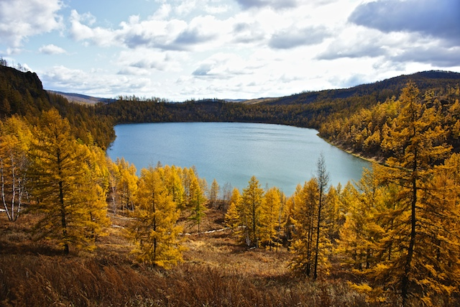
Photo: Late fall at the Arxan National Park (Photo by Jia Wang@ Flickr)

The Inner Mongolia Da-xing-an-ling (Greater Khingan Mountains) is located in the north end of China’s territory, adjacent to Mongolia and Russia. It maintains some of the last pristine natural area in China, also one of the largest state forest areas in China with abundant wild plants and animal resources. In addition to the magnificent northern Eurasia forests, there are also well-developed grassland and wetland ecosystems with over 700 rivers flowing in the area. Several national parks in the area are rated as the country’s best travel destinations.
The state managed forests in the area cover 81.7 thousand Km² with over 0.89 billion m³ of standing forest stock which ranks the 1st among all state forests in China. It also plays an important role as carbon storage for mediating climate change. Timber harvest, non-timber forest products and processing industry are key components of the local economy.
In the field trip, we will visit state forest enterprises, as well as some of the iconic landscapes, and learn some important issues surrounding state forest management and history of reform and development in Northeast China Forests.

