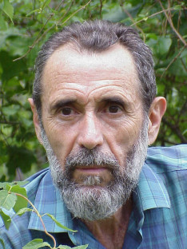 Dr. Boris Zeide (1937-2012)
Dr. Boris Zeide was born and educated in Moscow, Russia. After much travel (holding faculty positions at Hebrew and Rutgers universities, as well as being a Bullard Forest Research Fellow at Harvard Forest and assuming a number of visiting positions throughout the world), Boris found rural Arkansas to his liking. He was Professor of Forestry at the University of Arkansas until he retired from the faculty in 2008. He moved with his wife, Elizabeth Zeide, to Georgia.

Whenever possible he took time to walk in the woods, taking different paths, depending on the location of the seasonal mushrooms, herbs, berries, grapes, and other fruits. He loved to walk in the woods.
He was known for innovative approaches to modeling of forest stand dynamics, the discovery of two basic forms behind existing growth equations, and his research in fractal geometry of tree crowns. Boris authored approximately 200 publications dealing with these topics. Part of his valuable legacy in the area of quantitative ecology and environmental issues, such as biodiversity and ecosystem management, is summarized in a paper titled “The Science of Forestry”*. He left us on March 1, 2012.
His memory and legacy will be kept within the forest science community.

Teresa Fidalgo Fonseca
Margarida Tomé
Harold Burkhart

* Zeide, B. 2008. The Science of Forestry. Journal of Sustainable Forestry, Vol. 27(4):345-473.

