POSITION DESCRIPTION

Position Title | Research Leader – Plant Propagation and Automation
Reports To | Science Leader, Forest Genetics
Purpose of Position | - Responsibility for the Tissue Culture Lab and the Scion Nursery.  - Provide leadership, nurture capability, and build revenue in the field of plant propagation and the research areas of tissue culture, nursery science and operations, and automation. The Research Leader (RL) will have specialised capability in one or more of the research areas and lead large project(s) of research in the area(s).
Organisational Values | 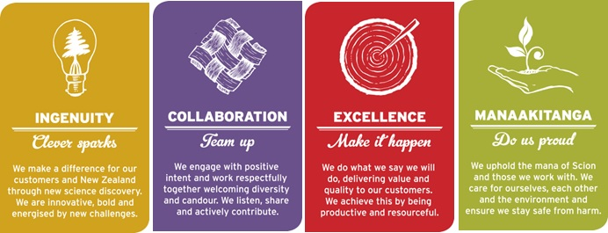
Key Result Areas  (Key Accountabilities) | - To nurture capability in the Plant Propagation and Automation (PPA) team, contribute to science team management and sustainability, plan and lead research projects and/or programme(s), be a role model for Scion’s organisational values, and actively support the development of a high performance customer-centric culture.  - To lead domestic and international R&D and consultancies in the field of plant propagation to develop state-of-the-art technologies for mass propagation of improved tree germplasm for the forest industry.  - Primary focus will be on radiata pine with an essential secondary focus on indigenous species, e.g., tōtara and other exotic tree species such as hybrids, eucalypts, cypresses, and Douglas-fir.  - Excellent communication skills and the ability to contribute to the integration of diverse areas of science, particularly across forest health, forest systems, forest informatics, and biotransformation.  - The Research Leader will lead or contribute to funding applications involving the internal science team and external clients, in order to build the science quality and science impact in New Zealand.  - Ensure compliance with Scion's Health & Safety Policy, and take a proactive approach to ensuring that all work practices are safe.  - Undertake additional projects, as required.
Role Competencies  (The skills, knowledge and behaviours essential to achieve effective performance in the role) | - PhD in a plant science related field, e.g., genetics, epigenetics, physiology, tissue culture, nursery culture.  - Minimum of 5 years research experience in plant propagation, e.g., tissue culture (e.g., somatic embryogenesis, organogenesis), or nursery science and operations (e.g., above- and below-ground biologicals, containerized and bare-root cropping); ideally with complementary automation experience (e.g., robotics, remote sensing).  - Capability to lead tissue culture integration with research and commercial nursery practice using state-of-the-art automation technologies.  - Demonstrated capability to interact with industry, with preference given to those involved in or with connections with the forestry industry.  - Recognised scientific standing based on publication record and/or scientific outputs, and domestic and international peer perception.  - Sound knowledge of science ethics, principles, and practices.  - Scion Way champion, and Scion's science and technology business.  - Capability to see fundamental science through to commercial application; and demonstrate creativity, foresight, and mature judgments in conducting research programmes.  - Capability to effectively lead a team to embrace Scion Values, including the emotional intelligence to demonstrate a positive attitude and deal constructively with team behaviours contrary to Scion Values.  - Excellent communication and written skills.
Relationships | - Internal  - Management Tiers 3 and 4, and Science and Corporate staff.  - Biotransformation, Forest Protection, Forest Industry Informatics, Forest Systems, Finance, Research and Investment Office, Business Development and Commercialisaiton, Project Support Office.  - External  - Forest growing companies  - Forest biotechnology companies  - NZ Forest Owners Association  - Domestic and international universities
Financial Accountability | - Authority to spend – Scion Delegation Authority Manual – Tier 4  - Budgetary Responsibility – Scion Delegation Authority Manual – Tier 4
People Management Responsibility | - Number of Direct Reports – 10 to 15, including Tissue Culture and Nursery sub-teams.
Targets to be Achieved | - As per agreed ACE Plan upon appointment, then annually.

