POSITION DESCRIPTION

Position Title | Scientist, Tissue Culture (Assistant Research Leader)
Reports To | Research Leader (RL), Plant Propagation and Automation − Forest Genetics
Purpose of Position | - Responsibility for the Tissue Culture Lab (on-delegation from the RL).  - In close cooperation with the RL, provide leadership, nurture capability, and build revenue in the field of plant propagation and the research area of tissue culture and automation.
Organisational Values | 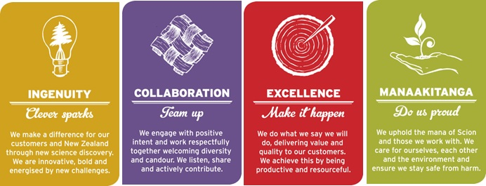
Key Result Areas  (Key Accountabilities) | - Co-lead and undertake with the RL, domestic and international R&D in tissue culture and its integration with nursery practice to develop state-of-the-art protocols and technologies for mass propagation of improved tree germplasm for the forest industry.  - Co-lead and undertake with the RL, internal science team management and sustainability, plan and lead small to large research projects, and be a role model for Scion’s organisational values.  - Lead and contribute to tissue culture cell line optimisation through continuous improvement principles with effective change management strategies for lab operations.  - Monitor and report to the RL on tissue culture lab performance. Identify opportunities for improvement and determine the ongoing needs of the lab to enable it to operate at optimum levels.  - Ensure compliance with Scion's Health & Safety Policy, and take a proactive approach to ensuring that all work practices are safe.  - Primary focus will be on radiata pine with an essential secondary focus on other exotic tree species such as hybrids, other pines, eucalypts, cypresses, Douglas-fir, and indigenous species (e.g., kauri).  - Excellent communication skills and the ability to contribute to the integration of diverse areas of science, particularly the Nursery, Forest Protection, and Biotransformation.  - Co-lead with the RL, funding applications involving the internal science team and external clients, in order to build science quality and impact in New Zealand.  - Assist the RL to prepare annual budgets, monthly financial planning documentation, and monthly science reporting.  - Undertake additional projects, as required.
Role Competencies  (The skills, knowledge and behaviours essential to achieve effective performance in the role) | - PhD or MSc (or equivalent) in the field of plant propagation and the research area of tissue culture.  - Minimum of 5 years research experience in tissue culture (e.g., protocol optimisation for somatic embryogenesis, organogenesis, and cryogenic protocols), and ideally with complimentary automation experience (e.g., robotics).  - Capability to co-lead tissue culture integration with research and commercial nursery practice using state-of-the-art automation technologies.  - Demonstrated capability to interact with industry, with preference given to those involved in or with connections to the forestry industry.  - Recognised scientific standing based on publication record and/or scientific outputs, and domestic and international peer perception.  - Sound knowledge of science ethics, principles, and practices.  - Scion Way champion, and Scion's science and technology business.  - Capability to see fundamental science through to commercial application; and demonstrate creativity, foresight, and mature judgments in conducting research programmes.  - Capability to effectively co-lead a team to embrace Scion Values, including the emotional intelligence to demonstrate a positive attitude and deal constructively with team behaviours contrary to Scion Values.  - Excellent communication and written skills.
Relationships | - Internal  - Management Tiers 3 and 4, and Science and Corporate staff.  - Biotransformation, Forest Protection, Forest Industry Informatics, Finance, Research and Investment Office, Business Development and Commercialisaiton, Project Support Office.  - External  - Forest growing companies  - Forest biotechnology companies  - NZ Forest Owners Association  - Domestic and international universities  - Automation expertise and technology companies
Financial Accountability | - Authority to spend – Scion Delegation Authority Manual – Tier 4  - Budgetary Responsibility – Scion Delegation Authority Manual – Tier 4
People Management Responsibility | - Number of Direct Reports – 5 to 7, on-delegation from RL
Targets to be Achieved | - As per agreed ACE Plan upon appointment, then annually.

