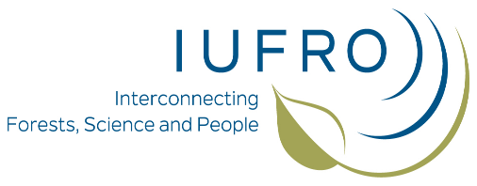

AForGeN
www.aforgen.org
AForGeN is a network of scientists who share an interest in the genetic resources of high mountain forests. The aim of the network is an intensive exchange of information and the development of a cross-border research network for the study of adaptation processes in alpine forest ecosystems.

Invitation to the 8th AForGeN meeting
Date: 12-14th June 2019

Location:
Chalet Le Dahut, Mont Ventoux, France.
coordinates: 44°11'02.8"N 5°15'58.2"E (44.184118, 5.266155)
http://www.stationdumontserein.com/services/chalet-le-dahut/
Venue:
The closest airport is Marseille Provence, the closest main train station is Avignon (easy connection from Paris and Marseille and major cities by bullet train).
Program:
Arrival on 11th June, departure 14th June, afternoon
12th June, Wednesday: research presentations
13th June, Thursday: field trip
walk to a mixed beech fir forest and a Mediterranean-Alpine grassland, up to the summit
14th June, Friday: AForGeN business meeting and departure

Accomodation and prices:
Chalet Le Dahut - capacity for lodging 36 people, in 4 rooms, mountain-style!
Fee: 10 Eur/night
Other lodging opportunities nearby in walking distance offering double, triple, quadruple rooms:
Chalet InterClub (http://chaletinterclub.com/):
Fee: 35-50 Eur/night

Camping Le Mont Serein (https://www.campingventoux.com/):
Fee: 20-100 Eur/night

Meals: in Chalet Interclub
Fees: dinners 15 Eur; breakfast 5 Eur

Contact: Bruno Fady, email: bruno.fady@inra.fr

Looking forward to meet you in the beautiful and famous Mount Ventoux!

